City of Greater Sudbury
Bicycle Advisory Panel

Bicycling Master Plan for the City of Greater Sudbury

Table of Contents
Introduction 1
Benefits of Cycling 1
Existing Infrastructure 1
Sudbury’s Obstacles to Bicycling 2
Goals for Sudbury’s Bicycle Network 2
Bicycle Infrastructure Types 2
Dedicated Bicycle Lanes 3
Paved Shoulders with Rumble Strips 4
Shared Roadways 4
Paved Multi-use Pathways 5
Physically Separated Cycle tracks 5
Comparison of Dedicated Bicycle Lanes versus Physically Separated Infrastructure on Boulevards 6
Bicycle Parking 8
Rack And Roll Program 8
Bicycle Infrastructure Considerations 9
Traffic Calming 9
Traffic Control Systems 10
Bicycle Route Markers 11
Bicycle Infrastructure Costs 12
Nomenclature of Bicycle Corridors 14
Arterial Bicycling Corridors 14
Local Bicycling Corridors 15
Off-Road Bicycling Connectors 15
Route Recommendations 15
Short-Term 15
Paris Street and Notre Dame Avenue (MR-80) 15
MR-39 Ramsey Lake Road 17
Falconbridge Road 18
MR-35 (Old Highway 144) 18
Mountain Street 19
Elgin Street 19
Bell Park Maintenance Road 20
MR-66 Barry Downe Road 20
Medium Term 21
MR-35 (Azilda and Chelmsford) 21
Notre Dame Street (Azilda) 21
MR-80 (Valley East) 22
Jeanne D’Arc Street (Val Thérèse) 22
Elmview Drive (Val Thérèse) 23
Dominion Drive (Val Thérèse) 23
Kathleen Street 24
Mackenzie Street 24
Church Street 25
Spruce Street 25
Second Avenue 26
Donna Drive 26
Balsam Street 27
Long Lake Road (MR-80) 27
Loach’s Road 28
Algonquin Road 28
Countryside Drive 29
Walford Road 29
McLeod Street 30
York Street 30
Main Street (Val Caron) 31
Errington Avenue (Chelmsford) 31
Main Street East (Chelmsford) 32
Montée Principale (Azilda) 32
Frood Road 33
Melvin Avenue, Dell Street, Bruce Avenue and Cambrian Heights Drive 33
Mabel Avenue, Morin Avenue and Wilma Street 34
Lansing Avenue 34
Lamothe Street 35
Paquette Street 35
Auger Avenue 35
Gemmel Street 36
Attlee Avenue 36
Soloy Drive 37
Belfry Avenue 37
Roy Avenue 37
Woodbine Avenue 38
Beaumont Avenue, Moss Street and Grandview Boulevard 38
Montrose Avenue 39
Holland Road 39
Lillian Boulevard 40
Kelly Lake Road 40
Southview Drive 41
Bouchard Street 41
Marcel Street, Yale Street, Barbera Street 42
Arnold Street, Moonrock Avenue, Brenda Drive and St. Charles Lake Road 42
Martindale Road 43
Charlotte Street 43
Hyland Drive 44
Winchester Avenue 45
Riverside Drive 45
Worthington Crescent 46
Bay Street, Adelaide Street 46
Logan Avenue, Mary Street, Glover Avenue, Rowat Street 46
Regent Street and Beatty Street 47
Ontario Street and Cross Street 47
Bancroft Drive/ Allan Street (MR-67) 47
Howey Drive, Bellevue Drive and Bancroft Drive (MR-67 and MR-70) 48
Rotary Park Trail 49
Long Term 49
Maley Drive 49
Lasalle Boulevard 50
Valleyview Road (Val Caron) 50
Notre Dame Avenue (Hanmer) 51
Linden Drive (Hanmer) 51
MR-84 (Capreol Road) 52
Moonlight Beach Road 52
MR-15 (Chelmsford) 52
Bonin Road, Montée Rouleau, St-Laurent Street 53
Martin Road (Val Caron) 53
Lonsdale Avenue 54
Carr Street 54
Selkirk Street 54
Burton Avenue 55
Future Roadway Construction 55
Appendices 56
Definition of Terms 56
Dedicated Bicycle Lane Configurations 57
Useful Resources 62
Bicycling Infrastructure Improvements Summary Chart 64

Introduction
As energy costs continue to rise, traffic congestion increasingly causes bottlenecks and pollution from automobiles continues to grow as a major environmental concern, the future for bicycling as an alternate means of transportation continues to look more promising.
However, for the profile of bicycling to grow among the general population, two major changes must occur: education about the benefits of bicycling must become more widespread and bicycling infrastructure must be significantly improved to accommodate the safe and practical travel of bicycles on roadways, many of which were designed with little or no regard for cyclists.
In the case of the City of Greater Sudbury, both of these factors will play a major role in increasing the safety and practicability of bicycling as a means of transportation, however infrastructure remains the biggest limiting factor to an increasing in bicycling traffic.
This document briefly overviews the recommendations of the City of Greater Sudbury Bicycle Advisory Panel for infrastructure improvements necessary for cycling to be a safe, practicable alternative means of transportation in the City. These recommendations are based upon successful bicycling blueprints from other North American jurisdictions, which should prove useful in achieving similarly successful results in the City of Greater Sudbury.

Benefits of Cycling
A bicycle is a vehicle unlike any other. It is both a form of transportation and recreation. It is a quick and efficient way of navigating an urban area. Bicycles are a means to a cleaner environment since they do not emit air pollution and have negligible greenhouse gas emissions. They are a means to improving an individual’s and the community’s overall health. Moreover, bicycles are easily accessible and very cost-effective.

Existing Infrastructure
Currently, as of 2010, the City of Greater Sudbury only has two dedicated bicycle lanes, along the Howey, Bellevue, Bancroft corridor, totalling 7.5 kilometres. Also, there is a 600-metre multi-use path along Paris Street from Ramsey Lake Road to York Street. Lastly, there are a network of off-road trails, some of which are navigable by bicycle. More information on these off-road trails is provided by Rainbow Routes in their trail map, available online at <http://rainbowroutes.com/>.
In comparison to other Ontario cities, Sudbury substantially lags behind. Burlington, roughly the same population as Greater Sudbury, has 42 km of dedicated bicycle lanes as of 2009. Many other cities, including Waterloo, Toronto, Ottawa, Hamilton and North Bay have considerably more kilometres of bicycle infrastructure per capita than Greater Sudbury.

Sudbury’s Obstacles to Bicycling
The City of Greater Sudbury is a very geographically disperse or sprawled conurbation. According to the 2006 Canadian Census, the average commute for a Sudburian lies between 5 to 7 km. This distance can be bicycled in 20 to 30 minutes, on average. Therefore, distance is not a barrier to many Sudburians to bicycling to work or school. However, due to the lack of a grid network of roadways, seldom alternatives exist to bicycling along arterial roadways for many Sudbury residents. For this reason, adequate bicycle infrastructure along identified corridors must be a top priority to increase the safety and practicality of bicycling in the City of Greater Sudbury.
The 2010 Sustainable Mobility Plan for the City of Greater Sudbury rates bicyclist safety, weather, lack of secure bicycle parking and lack of access to a bicycle as the top barriers to bicycling by survey respondents.
Thus, the Bicycle Advisory Panel recommends that these barriers be addressed by: building a safe and practical bicycle network on key roadways; encouraging secure bicycle parking;working with community organizations to loan bicycles to low-income individuals; and, educating motorists and bicyclists on how to share the road and operate both vehicles safely.

Goals for Sudbury’s Bicycle Network
It requires planning, hard work and dedication to transform a former moonscape into a diverse greenscape. However, the efforts of municipal employees, corporations and citizens has accomplished exactly that. However, now that the Sudbury landscape has been regreened, it is time for another goal: greening the Sudbury transportation network.
Albeit a lofty goal, the Greater Sudbury community has demonstrated that such goals are realizable. This Bicycle Master Planis a blueprint for the goal of a cycle-friendly community intended to supersede the Sustainable Mobility Plan’s cycling component and implemented in conjunction with its Pedestrian and Transit components. Although this Plan is as detailed possible, is it nevertheless recommended that City of Greater Sudbury staff and Council continue to consult with the City of Greater Sudbury Bicycle Advisory Panel on all bicycle infrastructure projects.

Bicycle Infrastructure Types
Before deciding on the best-suited bicycle infrastructure solution, the needs of cyclists must be considered. Reiterating, people include safety and secure bicycling parking as key factors in their decision whether to cycle.
To address safety while bicycling, it first must be noted that bicycling is not an intrinsically dangerous activity. A cyclist riding on the road or in a bicycle lane, following the rules of the road, is at a negligible chance of being hit by a motor vehicle. Moreover, the significant health benefits of bicycling must be taken into account when considering the overall risk of bicycling.
Safety while bicycling can be improved by smart bicycle infrastructure choices. A cyclist needs to ride at least 1 metre from the curb to avoid hazards, such as storm sewer grates, potholes, sand and other debris. Moreover, motorists must give at least 1 metre when passing a cyclist. Thus, adequately wide bicycle lanes are an important consideration. Other important considerations for safe and practical bicycling are ensuring that bicycle infrastructure has a smooth asphalt surface, to minimize collisions or falls caused by unexpected changes in the road surface. Uneven surfaces, such as those encountered on boulevards, the asphalt strip between the curb and the sidewalk, are very hazardous to cycling due to their highly uneven surface.
When designing bicycling infrastructure, it is also important to consider the directness and convenience of bicycle routes: bicyclists are less likely to ride on routes that take them far out of their way, or that require them to make an unreasonable amount of turns or stops to continue on a bicycle route.
A good bicycling network should be designed keeping the following needs of cyclists in mind at all times:
- safety: infrastructure should be designed to standards so that bicyclists and motorists have adequate space, and that motorists and bicyclists are deterred from taking risks;
- directness: bicyclists want to go somewhere; very indirect routes will be avoided by many cyclists. Unnecessary stopping will also deter bicyclists or will encourage risk-taking;
- comfort: bicycle infrastructure surfaces should be designedto standard, i.e., bicycle lanes and multi-use paths should have a smooth and consistent surface;
- coherence: a bicycle network should go somewhere, if it is to be used. Utilitarian routes can also be used recreationally; whereas, the opposite is not true. The following recommendations outline a coherent, integrated bicycle network for the City of Greater Sudbury.

Dedicated Bicycle Lanes
Dedicated bicycle lanes are a portion of a roadway or shoulder that have been designated for the exclusive use of bicyclists by signage and pavement markings. Private motor vehicles are not allowed to park in or travel on bicycle lanes, with the exception of crossing them perpendicularly and making turning movements onto an intersecting roadway. Public transit vehicles are allowed to stop in bicycle lanes to allow passengers to embark and disembark. Likewise, emergency vehicles may travel or park in bicycle lanes while on duty. The goal of dedicated bicycle lanes is to reduce conflict with pedestrians and motorists by providing bicyclists with a dedicated space, thus improving safety for all roadway users.
Bicycle lanes have many possible configurations; the most applicable to Sudbury are listed in Dedicated Bicycle Lane Configurations on Page 57.
All dedicated bicycle lanes should be properly marked on the roadway and signed. Standards for bicycle lane markings and signage can be found in TAC Guidelines for Design and Application of Bikeway Pavement Markings.

Paved Shoulders with Rumble Strips
The City of Greater Sudbury possesses many rural roadways that connect outlying communities with the City proper. Such roadways typically have speed limits ranging from 60 km/h to 80 km/h. Do to these high speeds, a buffer between motor vehicle and bicycle traffic can be employed, such as rumble strips.
The new standard when reconstructing said roadways is to include a 1.5- to 2-metre paved shoulder on each side of the roadway, typically separated from the travel lanes by the use of rumble strips. This practice is cyclist-friendly and should be encouraged whenever possible.
There are two major downsides with this roadway treatment, however. Sometimes rumble strips are not ended before intersections, causing possible issues for bicyclists who must therefore cross rumble strips, which increases the likelihood of falls. If rumble strips are ended roughly 15 metres before intersections, this problem is avoided.
Moreover, shoulders tend to accumulate debris from roadways, and are not swept often or at all, in some cases. The City of Greater Sudbury should implement a policy that all shoulders along bicycle routes and bicycle lanes are properly swept each spring and half-way through the summer, to remove rocks, sand and other debris that can harm a cyclist.
Examples of roadways that are candidates for this treatment are MR-80 Long Lake Road from the Southwest Bypass to Tilton Lake Road; MR-80 from Lasalle Boulevard to McCrae Heights; MR-35 from Ethelbert Street to Notre-Dame Street (Azilda); Falconbridge Road from Maley Drive to Falconbridge along the rural, uncurbed sections.

Shared Roadways
A shared roadway is a lower-traffic, lower-speed roadway that does not require dedicated bicycle lanes. The outside travel lane on such roadways is shared between cyclists and motorists. Key features of a shared roadway are wide outside lanes, paved shoulders if there are no curbs, and modifications to make the roadway more bicycle-friendly, outlined in the Bicycle Infrastructure Considerations section on page 9.
Another key element of shared roadways is the use of bicycle sharrows or shared roadway markings. When traffic lanes are too narrow to accommodate dedicated bicycle lanes, sharrows can be used to alleviate problems of bicycles riding too close to the curb or too close to parked cars. Sharrows aim to show bicyclists the safest lane position to avoid obstacles and to encourage cyclists to ride in a predictable line. Sharrows also serve to alert motorists to the presence of bicyclists and remind them to share the road. A typical sharrow is illustrated in Figure 1.
Figure 1—Bicycle Sharrow
For shared roadways with little on-road parking, the centre of the sharrow marking should be roughly 1 metre away from the curb or edge of the roadway. When on-street parking is present, the centre of the sharrow should be 2.5 to 3 metres away from the curb or edge of the roadway. Alternately, if the roadway has wide lanes, the centre of the sharrow should be placed 2 to 2.5 metres from the centre of the roadway so that bicycles are visible to motorists.

Paved Multi-use Pathways
In the context of this document, paved multi-use paths shall be defined as two-way physically separated infrastructure in a rural area engineered for use by pedestrians and cyclists. This differs from physically separated cycle paths in that paved multi-use paths should only be used along roadways in rural areas or along a dedicated right of way separate from motor vehicle roadways.
Such infrastructure must be placed either at a distance far enough away from roadways so that right- and left-turning motor vehicles are not a hazard to cyclists, or designed so that there are a minimum of crossings, i.e., potential conflict zones, between the multi-use path and intersections.
Multi-use paths are primarily useful in areas where no roadway currently exists and a safer, more convenient path can be established for cyclists along a new right-of-way. They are also a safe alternative to paved shoulders on highways with high traffic volumes and speeds of 80 km/h or greater, as long as the multi-use path has a minimum of intersections, including driveways.
Key elements of a successful multi-use path are:
- a paved surface on said path so that it is safe for cyclists;
- a minimum of intersections so to avoid extremely dangerous collisions between cyclists and turning motor vehicles;
- a wide surface, at least 3 and ideally 4 metres wide, to accommodate safe passage for two-way pedestrian and cyclist traffic.

Physically Separated Cycle tracks
Cycle tracks are a segregated type of bicycle lane, physically separated from travel lanes, parking lanes and sidewalks by pavement colouring, bollards, curbs, raised medians or a combination of these elements.
Key design elements of cycle tracks are one-way traffic operation, i.e., a cyclist always cycles with traffic. Cycle tracks are engineered to have a quality travel surface, adequate width, drainage and signage. Moreover, physically separated cycle tracks must be designed so that the cycle track has the same right of way as the main roadway, otherwise cycling would be both unpleasant and dangerous.
However, physically separated cycle tracks are up to three times most costly per kilometre than a dedicated bicycle lane. The increase in safety for cyclists is negligible compared to dedicated bicycle lanes, since the risk of being rear-ended in a bicycle lane is very low. Although some cyclists may feel more comfortable with physical separation, it should be noted that for one kilometre of physically separated cycle track constructed, three kilometres of dedicated bicycle lane could be built for the same cost. Please see Error! Not a valid bookmark self-reference. on pagei for a detailed break-down of bicycle infrastructure costs.
Considering these factors, the Bicycle Advisory Panel is not recommending any physically separated cycle tracks in the City of Greater Sudbury.
Moreover, it should be noted that a physically separated cycle track is completely incompatible with boulevards, the asphalt strip between the curb and the sidewalk. Boulevards do not provide an adequate travel surface due to their bumped nature; they have many obstacles such as signs and light standards and are not separated from pedestrians. Moreover, boulevards cannot have the same right of way as the main road, meaning that bicycles must cross intersections by dismounting and walking across since the boulevard is considered part of the sidewalk as per the Ontario Highway Traffic Act. Please see the next section for a detailed examination of why boulevards are a poor candidate for bicycle infrastructure, compared to dedicated bicycle lanes.

Comparison of Dedicated Bicycle Lanes versus Physically Separated Infrastructure on Boulevards
There has been some discussion in the City of Greater Sudbury to designate boulevards as bicycle paths, the paved strip of land between the roadway and sidewalk, reserved for signage, light standards and snow storage. The major benefits of boulevard-based paths are the perception of safety and the ability to sign such boulevards as bicycle paths without major infrastructure changes. However, the perception of safety on boulevards and sidewalks is a very false perception of safety. Dr. William Moritz found in his 1996 study Adult Bicyclists in the United States that sidewalk and boulevard-based bicycling is 20 times more dangerous than on-road cycling, compared to bicycling on an multilane roadway with a speed limit of 60 km/h or less and no bicycling infrastructure. When these multilane roadways have on-road bicycle lanes installed, there is an additional reduction in bicycle-related accidents of up to 38%.
In sum, bicycling on sidewalks and boulevard-based bicycle paths along roadways is considerably more dangerous than riding on the roadway itself. The probability of being read-ended on a bicycle is almost negligible, whereas the probability of being hit by a motorist making a turning movement when a bicyclist rides on a sidewalk or off-road path is significantly higher.
The chance of falling on a sidewalk or boulevard is very high, as well as potential pedestrian-cyclist conflict. The most dangerous aspect, however, is that motorists and bicyclists alike will not learn how to safely interact with each other if physically-separated infrastructure is pursued, potentially causing safety hazards in the majority of roadways which will not have dedicated bicycling infrastructure.
The merits of both boulevard-based bicycle paths and on-road bicycle lanes are contrasted in the following table:
Table 1—Contrasting Boulevard-based bicycle paths to On-road bicycle lanes
Boulevard-based bicycle paths | On-road bicycle lanes
- Little effort required to implement infrastructure | - Bicycle lanes are easily added when a roadway is reconstructed  - In the meantime, bicycle sharrows can have many of the positive effects as bicycle lanes
- Travelled surface has many obstacles, including road signs and light standards | - A bicycle lane has no obstacles within it, aside from transit vehicles when loading and unloading passengers
- Very frequent dips in the travelled surface, greatly increasing the likelihood of a cyclist falling | - A bicycle lane is constructed on even asphalt and storm sewer grates pose little hazard to bicyclists
- Enormous hazard to bicyclists from right- and left-turning motorists who do not look for bicyclists outside of the roadway | - Very minor chance of rear-end collisions on the roadway, almost negligible when on-road bicycle lanes are present
- Promotes poor bicycling habits, e.g., sidewalk riding and riding through cross-walks  - Promotes the motorists mentality that they do not have to share the road or pay attention to bicyclists | - On-road bicycle lanes encourage safe driving on the part of motorists and bicyclists alike  - Experience riding in bicycle lanes helps build safe bicycling skills that can be used on roadways with no bicycle infrastructure
- Encourages speeding and reckless driving on the part of motorists | - Bicycle lanes provide a beneficial traffic calming effect when properly designed
- Hazard to pedestrians | - No pedestrian-cyclist conflict

Thus, boulevard-based bicycling infrastructure should be avoided in most situations. However, it can possibly be used as a temporary, short-term measure before dedicated on-road bicycle lanes can be installed, provided that the following conditions are present:
- Boulevard-based cyclists only travel in the direction of motor vehicle traffic, so that the relative speed of cyclists to motorists is significantly reduced as opposed to riding counter-current to motor vehicle traffic;
- Boulevard-based cyclists ride at a maximum of 20 km/h so that motorists can better see cyclists and so that speed is reduced when cyclists interact or collide with pedestrians;
- Boulevard-based bicycling infrastructure is only installed in areas where there is at least a 1.5 metre continuous strip of asphalt between the sidewalk and the nearest obstacle, i.e., light standard, sign, or deflector curb; and,
- Boulevard-based bicycling infrastructure only be installed on roadways with at most 1 intersection every 250 to 500 metres, where an intersection is defined as any access point onto the roadway, whether it is a residential driveway, commercial driveway or roadway.
In conclusion, boulevard-based bicycle paths should be avoided. Instead, bicycle lanes should be recommended for installation as soon as possible, and bicycle sharrows should be installed in the meantime. Boulevard-based bicycle infrastructure should possibly be considered as a pilot project on: Paris Street from Ramsey Lake Road to Walford Road and MR-80 in Valley East where a boulevard exists and there is a low density of intersections along the roadway.
Bicycle lane safety can be further enhanced by adding a painted buffer area of 0.25 to 0.5 metres between the bicycle lane and the motor vehicle traffic. Physical separation via bollards, curbs or other means is excessively expensive and the safety benefit is negligible.

Bicycle Parking
Secure bicycle parking is an important element of a successful bicycling network. It is recommended that the City of Greater Sudbury consult the Bicycle Advisory Panel to draft a bylaw requiring buildings of a certain size to have bicycle parking. Such buildings include, but are not limited to, schools, shopping centres, office buildings, high-density residential buildings and all municipal buildings and parks.
The City of Toronto has recently drafted a bylaw requiring bicycle parking, which should serve as a good baseline for Sudbury’s bylaw. Please see Useful Resources on Page 62 for more information on Toronto’s proposed bicycle parking bylaw.
Moreover, not all types of bicycle racks are safe or useful. The Bicycle Advisory Panel has a Bicycles at Rest guide to bicycle storage, which can be borrowed from the BAP by any interested party.

Rack And Roll Program
As of 2009, Greater Sudbury Transit has bicycle racks on its 703—Val Caron, Hanmer, Capreol route. It is recommended that the Rack and Roll program be expanded to all of the outlying areas, i.e., the 103, 303, 701, 702 and 704 bus routes as soon as it is possible to expand the transit garage to accommodate the extra space required by more bicycle racks.
Moreover, it is a long-term recommendation that all Sudbury Transit routes eventually include bicycle racks, which would greatly encourage intermodal transportation and help cyclists in inclement weather.
It is also recommended that Greater Sudbury Transit develop a policy on taking bicycles onto busses without bicycle racks. Greater Sudbury Transit should determine a time window and/or other conditions where bicycles are allowed on busses. This policy should be publicized inside the Transit Guide and communicated with all Transit drivers.

Bicycle Infrastructure Considerations
Although the class of bicycle infrastructure is an important consideration, there are also other important considerations applicable to all types of infrastructure, namely, traffic calming, traffic control systems, bicycle route markers and infrastructure costs.

Traffic Calming
Many roadways face an increasing problem: speeding and unsafe motorists. Many Greater Sudbury roadways have issues with speeding or other unsafe driving practices. Along proposed bicycle routes, it is recommended that the following traffic calming techniques be applied where applicable.
First, it should be noted that the installation of dedicated bicycle lanes typically has a traffic calming effect, by narrowing or creating the impression of narrowing the travel lane. Therefore, in any traffic calming project, bicycle lanes should always be considered before more costly options.
The goal of traffic calming should be twofold: it should reduce the speed of vehicles travelling along a roadway and it should also aim to improve the flow of traffic, albeit at a lower speed. Anecdotally, frequent stop signs encourage aggressive acceleration among motorists, whereas a roadway with yield signs, roundabouts and mini-roundabouts encourage driving at a consistent but slower speed.
New road construction and traffic calming projects should utilize modern roundabouts and mini-roundabouts wherever possible, which act both as an effective traffic calming device and a traffic flow improvement device. Single-lane roundabouts are also better for cyclists, since right of way is more easily assigned and they reduce the need for full stops, which are tiresome for bicyclists. The City of Hamilton has recently introduced a policy to use roundabouts as a traffic calming device, to replace all-way stops and in lieu of installing traffic signals.
The construction of central traffic-calming islands should be avoided, since this narrows the travel lane significantly and causes conflict between motorists and bicyclists. Instead, speed humps, roundabouts and mini-roundabouts should be utilized. Alternately, islands should be constructed on near the edges of the roadway, so that the travel lanes are narrowed, but bicycles can still travel between the island and the curb.
On arterial roadways where speeding is a problem, measures to deter speeding include lowering speed limits, e.g., from 60 km/h to 50 km/h in urban sections of Paris Street. Where space permits, modern roundabouts are also very effective at calming traffic while promoting smooth traffic slow and increasing roadway capacity. Cyclists who are not comfortable riding in large roundabouts can always dismount and cross as a pedestrian, which is safer at roundabouts than at signalized intersections. Possible locations for roundabouts in the City of Greater Sudbury are the entrance to Laurentian University off of Ramsey Lake Road and the intersection of Ramsey Lake Road and Paris Street.
In sum, the effects of traffic calming should always consider its effects on bicyclists. Traffic calming options such as speed humps, roundabouts and mini-roundabouts and islands on the edges of roadways should be considered instead of islands in the middle of roadways.

Traffic Control Systems
Bicyclists expend a significantly greater amount of effort to accelerate from a full stop, as opposed to automobiles. For this reason, the excessive use of stop signs should be avoided. Alternatives to full stops and all-way stops include yield signs, roundabouts and mini-roundabouts, where they are appropriate. Another option is to turn stop signs so that bicycle routes have a minimum of stops, but intersecting roadways face a stop. All-way stops can also be replaced with one- or two-way stops where appropriate, giving bicycle routes the right of way.
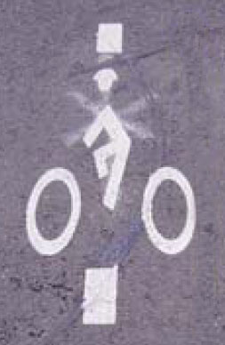
Roundabouts should be considered wherever an all-way stop or traffic signal is over capacity, where an all-way stop or traffic signals are being considered, as part of a larger capital project, e.g., road reconstruction, or where due to new development, intersections are to be created.
Moreover, traffic signal sensors pose a special problem to bicyclists, since they are considerably less sensitive to bicycles than they are to motor vehicles. Problematic sensor-actuated traffic signals along bicycle routes should have markings to denote the location of the sensor. Portland uses the marking in Figure 2 to identify the best location for bicyclists to stop to trigger a traffic signal.

Figure 2—Marking to Identify Traffic Signal Sensor

Bicycle Route Markers
Bicycle Route Markers are an important tool for cyclists to locate and navigate a bicycle route network. Some bicycle routes involve off-road segments or navigating away from arterial roadways where alternatives exist. The goal of bicycle route markers is to direct cyclists along the safest and most practical route, in conjunction with a Bicycle Route Map. Route markers can also assist cyclists with information that regular road signs cannot, such as an approximate time to reach a popular destination by bicycle.
Currently, there is no standard for bicycle signage in Canada. For this reason, a route signage system must be conceived for Sudbury. Key elements of a signage system are:
- consistent and predictable implementation across the bicycle network;
- pertinent information for cyclists, including the direction that the bicycle route follows, popular destinations and the distance to them;
- signage at regular intervals and in advance of intersections with other bicycle routes.
Examples of good bicycle route markers are listed in Figure 3. This Figure consists of bicycle route markers from the City of Toronto; the first sign is a confirmation that a person is on a bicycle route; the second shows choices to cyclists approaching an intersection of bicycle routes. It is recommended that Rainbow Routes and the Bicycle Advisory Panel be consulted to develop a bicycle route marker strategy for the City of Greater Sudbury as its bicycle network is implemented.
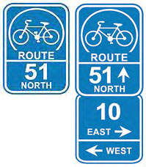
Figure 3—Examples of Bicycle Route Markers

Bicycle Infrastructure Costs
The City of Burlington calculated an estimated cost for various types of bicycling infrastructure as part of their Bicycle Master Plan. All unit costs are estimates; they do not include the cost of property acquisitions or major infrastructure changes, e.g., bridge widening or retaining wall relocation. Prices are based on average constructions costs from recent Southern Ontario projects.
Table 2—Estimated cost per kilometre for bicycle infrastructure types
Infrastructure | Cost per km | Assumptions
Dedicated Bicycle Lanes
Paint bike lanes on existing wide lanes / roadway or as part of road resurfacing  project (line painting and signage) | $10,000 | Paint bike lane lines, bicycle symbol and diamond every 200 m, bike lane signage every 300 m
Retrofit bike lanes to existing roadway (line removal, painting and signage) | $23,000 | Remove existing lines (assume four-lane roadway), repaint lane lines including bike lane, bicycle symbol and diamond every 200 m, bike lane signage every 300 m
Add bike lanes as part of road new construction / reconstruction / widening project | $116,000 | Additional pavement (granular and asphalt), paint bike lane lines, bicycle symbol and diamond every 200 m, bike lane signage every 300 m; removals, curb & gutter, utility leads included in road portion of construction costs
Pave existing granular shoulders as part of road resurfacing / reconstruction  project | $76,000 | Additional asphalt, paint bike lane lines, bicycle symbol and diamond every 200 m, bike lane signage every 300 m
Add paved shoulders as part of road new construction / reconstruction / widening project | $130,000 | Additional pavement (granular and asphalt), paint bike lane lines, bicycle symbol and diamond every 200 m, bike lane signage every 300 m; removals, grading, sub-drains included in road portion of construction costs
Shared Lanes
Add bicycle route signage rural area | $1,300 | One bicycle route sign with appropriate tabs (directions, destinations, distances, etc.) every 1 km, plus two on side streets every 1 km, additional route map sign every 5 km
Add bicycle route signage urban area | $2,800 | One bicycle route sign with appropriate tabs (directions, destinations, distances, etc.) every 300 m, plus two on side streets every 500 m, additional route map sign every 5 km
Add shared lane markings to existing travel lanes | $15,000 | Bicycle symbol and double chevrons every 75 m both sides, share the road signage every 300 m both sides
Create bicycle priority street | $76,000 | Traffic calming, major roadway crossing (detection and bike box, median refuge, or signalization every 1.5 km), bicycle route sign with tabs (directions, destinations, distances, etc.) every 300 m
Physically Separated Cycle Tracks
Construct cycle tracks adjacent existing roadway | $470,000 | 2.0 m wide with boulevard side curb, travel lane delineation / curb, cycle track pavement, bicycle symbol and diamond every 200 m, bike lane signage every 300 m, major intersection bicycle signals every 600 m, minor side street / driveway modifications
Construct cycle tracks as part of road new construction / reconstruction / widening | $320,000 | 2.0 m wide with travel lane delineation / curb, cycle track pavement, bicycle symbol and diamond every 200 m, bike lane signage every 300 m; removals, grading, boulevard side curb, additional bicycle traffic signal heads; signalization and side street / driveway modifications included in road portion of construction costs
Paved Multi-Use Paths
Pave existing granular pathway and add signage | $45,000 | 3.0 m wide
Widen and resurface existing asphalt pathway and add signage | $110,000 | Widen from 3.0 m to 4.0 m
Construct new multi-use asphalt pathway with signage | $200,000 | 4.0 m wide, normal site conditions
Construct new multi-use concrete pathway with signage | $200,000 | 3.0 m wide, normal site conditions
Upgrade existing multi-use trail including crossings and signage | $390,000 | Widen from 3.0 to 4.0 m, and improve minor and major street crossings

Nomenclature of Bicycle Corridors
Based on the above background information, the suggested plan for improving bicycling infrastructure in the City is categorized into three major categories: Arterial Bicycling Corridors, Local Bicycling Corridors and Off-Road Bicycling Connectors. These three categories are further classified based on the realistic time frame for completion of bicycling infrastructure improvements: Short Term, under 5 years; Medium Term, 5 to 10 years; and Long Term, 10 to 20 years.

Arterial Bicycling Corridors
Due to the sprawled nature of the City of Greater Sudbury conurbation, the use of arterial thoroughfares as part of a Bicycling Master Planis unavoidable. Nevertheless, wherever safe and practical alternatives to major thoroughfares exist, the alternatives will be recommended as a bicycling route instead of the arterial road.
Bicycling infrastructure improvements on arterial roads are ideally: dedicated bicycle lanes for urban roadways with speed limits of 60 km/h or less. On rural roadways with speed limits of 80 km/h or greater, two options should be considered to improve bicycling safety and practicality: paved off-road multiuse paths should be considered or paved shoulders with rumble strips. Part of a successful Bicycling Master Plan may include the possibility of lowering the speed limit on certain sections roadways, where the posted limit is too high for given traffic patterns and development.
It is suggested that in the Short Term and Medium Term, where is it unfeasible to build dedicated bicycle infrastructure due to financial constraints that bicycle sharrows be installed, which have been shown to increase safety for bicyclists and motorists alike.
Bicycle sharrows are shared road markings used throughout Europe and North America where, for whatever reason, dedicated bicycling infrastructure is unfeasible. Sharrows consist of a double-chevron pointing in the direction of traffic flow with a bicycle logo painted below the chevron. The chevron is painted a sufficient distance from the edge of the roadway so that it provides a safe path of travel for the bicyclist on the given roadway. Sharrows act to alter motorists to the presence of bicyclists and reinforce a cyclist’s right to the road, and they demonstrate to a cyclist where he or she should be riding on a roadway under normal conditions. Sharrows should always be used in conjunction with Share the Road signage and a clear Bicycle Route Marker system.
In sum, the City of Greater Sudbury Bicycle Advisory Panel recommends that on arterial roadways designated as Arterial Bicycling Corridors that: dedicated bicycle lanes be installed on urban roadways and paved shoulders or off-road bicycling paths on rural roadways; speed limits on some dangerous arterial roadways be lowered in sections where there has been in increase in urbanization; and that bicycle sharrows be installed in the short term along with Share the Road signage and Bicycle Route Markers.

Local Bicycling Corridors
Although not abundant, there are nevertheless several minor thoroughfares in the City of Greater Sudbury which are candidates for safe and practical Local Bicycling Corridors, such as Algonquin Road in the South End of Sudbury. These Local Bicycling Corridors are recommended to be improved by the installation of bicycle sharrows, Share the Road signage and Bicycle Route Markers, as part of a numbered Bicycle Route System for the City of Greater Sudbury. Due to the lower traffic volumes and wider curb lanes typical of most minor thoroughfares, dedicated bicycle lanes are typically discouraged as opposed to bicycle sharrows and good route signage. Minor thoroughfares with low traffic volumes can have hazards near the edge of the roadway which typically create a dangerous area where dedicated bicycle lanes are typically painted.

Off-Road Bicycling Connectors
The final yet vital contributor to a successful Bicycle Master Plan is Off-Road Bicycling Connectors, usually shorter trails that connect neighbourhoods or suburbs to each other where no paved roadway exists. These connectors are vital since they provide shorter, safer alternatives to arterial roads. It is recommended that Off-Road Bicycling Connectors be investigated in collaboration with Rainbow Routes wherever there is an existing trail that should be improved, or included as part of the Bicycle Route System for the City of Greater Sudbury.

Route Recommendations
A successful Bicycle Master Plan must take in to account many factors, including bicyclist demographics, common journey start points and end points, traffic volumes, traffic speed, necessary space for bicycle infrastructure improvements, the realistic time frame required for improvements on a given roadway and the overall characteror feelof a given roadway chosen to be part of the Bicycle Route System.
The Bicycle Advisory Panel has taken all of these factors into account in drafting the below recommendations for the Short Term, Medium Term and Long Term time frames.

Short-Term
The following recommendations are those identified by the Bicycle Advisory Panel as integral corridors that must have bicycling infrastructure improvements in one to five years. These corridors are vital links in a successful Bicycle Route System for the City of Greater Sudbury and realistic infrastructure improvements that can be completed in this time frame are listed.

Paris Street and Notre Dame Avenue (MR-80)
Paris Street and Notre Dame Avenue, MR-80, is an arterial road that travels from the Long Lake area to Hanmer. The MR-80 corridor connects the South End, Long Lake, Hanmer and New Sudbury areas to Downtown. There are many primary and secondary schools, medical offices, places of employment and shopping areas located on or very near MR-80. This roadway is the main access for Laurentian Hospital, Science North and Laurentian University, three of the City of Greater Sudbury’s top destinations. The density of housing and businesses along MR-80 is one of the highest in the City. For all of the above reasons, the Bicycle Advisory Panel believes that the MR-80 corridor is the highest-priority roadway for bicycle infrastructure improvements, from Regent Street to Lasalle Boulevard.
Due to the length of MR-80, it has been subdivided into several lengths with different infrastructure improvements necessary and different time frames for completion:
Paris Street (MR-80) from Regent Street to Ramsey Lake Road:
Category | Arterial Bicycling Corridor
Timeframe | Short Term
Priority | 1 – Highest
Infrastructure Improvements Necessary | - Share the Road signage erected at 1-kilometre intervals  - Bicycle Sharrows installed in the curb lane, 1 metre from the curb  - The installation of dedicated bicycle lanes is recommended as soon as possible  - Lowering the speed limit from 60 km/h to 50 km/h to increase safety along this roadway  - Bicycle Route Markers installed
Rationale | - Access from South End (Four Corners) to Laurentian Hospital, Laurentian University and Science North  - Access to medical offices, places of employment and shopping  - Connectivity between Bell Park Trail, leading to downtown, and the South End

Notre-Dame Avenue (MR-80) from Ste Anne Road to Lasalle Boulevard:
Category | Arterial Bicycling Corridor
Timeframe | Short Term
Priority | 1 – Highest
Infrastructure Improvements Necessary | - Share the Road signage erected at 1-kilometre intervals  - Bicycle Sharrows installed in the curb lane, 1 metre from the curb  - The installation of dedicated bicycle lanes is recommended as soon as possible  - Bicycle Route Markers installed
Rationale | - Access from Downtown to New Sudbury and Flour Mill  - Access to medical offices, places of employment and shopping  - Connectivity between Collège Boréal, low-income housing and businesses to Downtown and New Sudbury

Paris Street/Notre Dame Avenue (MR-80) from Ramsey Lake Road to Ste Anne Road:
Category | Arterial Bicycling Corridor
Timeframe | Short Term
Priority | 1 – Highest
Infrastructure Improvements Necessary | - Share the Road signage erected at 1-kilometre intervals  - Bicycle Sharrows installed in the curb lane, 1 metre from the curb  - The installation of dedicated bicycle lanes is recommended as soon as possible or whenever the roadway is reconstructed  - Lowering the speed limit from 60 km/h to 50 km/h between Ramsey Lake Road and York Street to enhance safety  - Bicycle Route Markers installed
Rationale | - Access from South End and Lockerby to Downtown  - Connectivity between Downtown and Laurentian Hospital and Laurentian University  - Connectivity between South End, New Sudbury and Lockerby areas to Downtown

MR-39 Ramsey Lake Road
MR-39 Ramsey Lake Road from Paris Street to South Bay Road
Category | Arterial Bicycling Corridor
Timeframe | Short Term
Priority | 2 – High
Overview | From Laurentian Hospital Access Road to South Bay Road, Ramsey Lake Road has paved shoulders suitable for bicycling. However, these shoulders are not signed as bicycle lanes and therefore cyclists cannot legally ride on the shoulders.
Infrastructure Improvements Necessary | - Share the Road signage erected at 1-kilometre intervals  - Bicycle Lanes installed along both shoulders from Laurentian Hospital to South Bay Road  - Bicycle Sharrows installed in the curb lane, 1 metre from the curb for the four-laned section from Paris Street to the Laurentian Hospital Access Road, leading cyclists to the new bicycle lanes once the paved shoulder begins  - Bicycle Route Markers installed
Rationale | - Access from Paris Street to Laurentian Hospital, Laurentian University and Science North  - Access to St Joseph’s Villa, Vale Inco Hospice and the Sudbury Regional Hospital Kirkwood Site  - Connectivity between Laurentian Conservation Area trails and Loach’s Trail to Paris Street

Falconbridge Road
Falconbridge Road from Maley Drive to Edison Road (Falconbridge)
Category | Arterial Bicycling Corridor
Timeframe | Short Term
Priority | 3 – High
Overview | Falconbridge Road is the only practical link between Garson, Falconbridge and New Sudbury. Currently, the uncurbed section of Falconbridge Road between Maley Drive and Garson has paved shoulders, ideal for bicycling. However, the curbed sections of Falconbridge Road require dedicated bicycling infrastructure to improve safety.
Infrastructure Improvements Necessary | - Share the Road signage erected at 1-kilometre intervals  - Paved shoulders separated from the roadway by rumble strips, 2 metres wide, to be installed along rural (uncurbed) sections of the roadway and designated for use by bicycles  - Bicycle Sharrows installed in the curb lane, 1 metre from the curb along the curbed sections of the roadway  - The installation of dedicated bicycle lanes along the built-up (curbed) sections of the roadway is recommended as soon as possible  - Bicycle Route Markers installed  - Speed limit of 80 km/h should be lowered to 60 km/h to improve safety along the length of Falconbridge Road, since excessive speeds are an issue in the roadway’s 60 km/h zones
Rationale | - Falconbridge Road is the only link between the core of the city and Garson and Falconbridge

MR-35 (Old Highway 144)
MR-35 from Lorne Street to Notre Dame Street (Azilda)
Category | Arterial Bicycling Corridor
Timeframe | Short Term
Priority | 4 – High
Overview | From Big Nickel Mine Road to Notre Dame Street in Azilda, MR-35 has wide shoulders to either side of the roadway which would be ideal for bicycling if they were properly marked and maintained. It is recommended that these paved shoulders are signed as bicycle lanes and be swept each spring.
Infrastructure Improvements Necessary | - Share the Road signage erected at 1-kilometre intervals  - Bicycle Lanes installed along both shoulders from Big Nickel Mine Road or Ethelbert Street to Notre Dame Street in Azilda  - Bicycle Sharrows installed in the curb lane, 1 metre from the curb for the section from Big Nickel Mine Road to Lorne Street, leading cyclists to the new bicycle lanes once the paved shoulder begins  - Bicycle Route Markers installed
Rationale | - Access between Azilda and Downtown  - Access between many residences and businesses in the West End and Downtown

Mountain Street
Mountain Street between Rotary Park Trail and Junction Creek Trail
Category | Local Bicycling Corridor
Timeframe | Short Term
Priority | 5 – High
Overview | Two important Off-Road Bicycling Connectors are the Rotary Park Trail, connecting New Sudbury to Downtown and the Junction Creek Trail, connecting the Flour Mill to Downtown. However, clearer markings are required to direct cyclists and pedestrians to the other trail or Downtown.
Infrastructure Improvements Necessary | - Bicycle Sharrows installed in the curb lane 1 metre from the curb along Mountain Street between the two trails  - Bicycle Sharrows installed in the curb lane 1 metre from the curb along Mountain Street and Louis Street to Ste Anne Road  - Bicycle Route Markers installed
Rationale | - Access from New Sudbury and the Flour Mill via an Off-Road Bicycling Connector  - Promotes bicycling between two large residential areas and downtown in an off-road environment

Elgin Street
Elgin Street/ Howey Drive from Mackenzie Street to Van Horne Street
Category | Local Bicycling Corridor
Timeframe | Short Term
Priority | 6 – High
Overview | The Minnow Lake bicycle lanes end at Van Horne Street, with no real connection to downtown. Bicycle sharrows are recommended on Elgin Street/ Howey Drive from Van Horne to Elm Street to connect Downtown to Minnow Lake safely.
Infrastructure Improvements Necessary | - Share the Road signage erected at 1-kilometre intervals  - Bicycle Sharrows installed in the curb lane, roughly 2 metres from centre of roadway so that bicycles travel a safe distance from parked vehicles, alleviating the hazard of opening vehicle doors  - Bicycle Route Markers installed
Rationale | - Access from Minnow Lake bicycle lanes to Downtown  - Directs bicycle traffic away from Minnow Lake to Downtown in the safest way possible  - Access to many Elgin Street businesses

Bell Park Maintenance Road
Bell Park Maintenance Road, Elizabeth Street and Edmund Street
Category | Local Bicycling Corridor
Timeframe | Short Term
Priority | 7 – High
Overview | Currently, the Rainbow Routes bicycle path terminates at the Grace Hartman Amphitheatre. It is recommended that a paved pathway is created along the route of the Bell Park Maintenance Road from the terminus of the current bicycle path to Elizabeth Street, so that bicycles may traverse Bell Park. Elizabeth Street and Edmund Street require proper signage to direct bicycles to Elgin Street via the pedestrian bridge.
Infrastructure Improvements Necessary | - Paved, properly signed bicycle pathway from Grace Hartman Amphitheatre to Elizabeth Street  - Bicycle Sharrows installed in the curb lane 1 metre from the curb along Elizabeth Street and Edmund Street to the Nelson Street pedestrian bridge  - Bicycle Route Markers installed
Rationale | - Access between Bell Park and Downtown, Minnow Lake and South End along a scenic route  - Discourages bicycles from the pedestrian-only Jim Gordon Boardwalk  - Promotes bicycling to Bell Park and helps complete a loop of Ramsey Lake by bicycle

MR-66 Barry Downe Road
MR-66 Barry Downe Road from Marcus Drive to Maley Drive
Category | Arterial Bicycling Corridor
Timeframe | Short Term
Priority | 8 – High
Overview | Due to the roadway network in New Sudbury, very few trips can be made without travelling on Barry Downe Road or Lasalle Boulevard. In this light, improvements must be made to these two arterial roads to make bicycling trips safer. Currently, there is not space for dedicated bicycle lanes, however dedicated bicycle lanes should be built whenever the roadway is reconstructed.
Infrastructure Improvements Necessary | - Share the Road signage erected at 1-kilometre intervals  - Bicycle Sharrows installed in the curb lane, 1 metre from the curb  - The installation of dedicated bicycle lanes is recommended as soon as possible  - Bicycle Route Markers installed
Rationale | - Connectivity between Downtown and Minnow Lake via Bancroft Drive and Second Avenue to New Sudbury  - Access to many medical offices, places of employment and shopping  - Access to Cambrian College

Medium Term

MR-35 (Azilda and Chelmsford)
MR-35 from Notre Dame Street West to MR-15 (Chelmsford)
Category | Arterial Bicycling Corridor
Timeframe | Medium Term
Priority | High
Overview | The communities of Chelmsford and Azilda are separated by a short distance, nearly all trips between the communities being under 10 km one way. However, cyclists face two dangerous roadways to complete the trip: MR-35 and MR-15. Paved shoulders marked for use by bicyclists on both roadways will greatly enhance safety for cyclists, especially younger cyclists who have limited options for travelling between the two communities for school and recreation.
Infrastructure Improvements Necessary | - Share the Road signage erected at 1-kilometre intervals  - The preferred option is physically-separated bicycle path to be built parallel to the roadway, providing a paved 3 to 4 metre surface for exclusive use of pedestrians and bicyclists  - Alternately, paved shoulders, 2 metres wide, to be installed and designated for use by bicycles  - Bicycle Route Markers installed
Rationale | - Connectivity between Chelmsford and Azilda  - Easier access to schools, medical offices and stores in the two communities

Notre Dame Street (Azilda)
Notre Dame Street (Azilda) from MR-35 (Azilda South) to MR-35 (Azilda North)
Category | Arterial Bicycling Corridor
Timeframe | Medium Term
Priority | High
Overview | Currently, Notre Dame Street in Azilda has paved shoulders for a portion of its length, providing a relatively safe corridor for cyclists, however signage along its length and markings at the two termini of the roadway are needed to improve cyclist safety. Sharrows should also be installed along the curbed sections of the roadway to prevent motorist-cyclist conflict.
Infrastructure Improvements Necessary | - Share the Road signage erected at 1-kilometre intervals  - Paved shoulders, 2 metres wide, to be designated for use by bicycles  - Bicycle Route Markers installed  - Bicycle Sharrows installed in the curb lane, 1 metre from the curb along the curbed sections of the roadway  - The installation of dedicated bicycle lanes is recommended when the roadway is reconstructed
Rationale | - Notre Dame Street is the main corridor in Azilda and is thus vital to improving cycling safety in the community  - The roadway provides access to most destinations in Azilda, including a bank, grocery store, convenience store, church and school

MR-80 (Valley East)
MR-80 (Valley East) from Lasalle Boulevard (New Sudbury) to Dominion Drive (Val Thérèse) and from Elmview Drive (Val Thérèse) to Notre Dame Avenue (Hanmer)
Category | Arterial Bicycling Corridor
Timeframe | Medium Term
Priority | High
Overview | MR-80 is currently the only way for cyclists to travel from Valley East to New Sudbury, albeit it is a dangerous roadway to travel due to high traffic volumes and high traffic speeds. It is imperative that uninterrupted paved shoulders be installed along the rural sections of the roadway and that dedicated bicycle lanes be installed as soon as possible to improve cyclist safety and to minimize motorist-cyclist conflicts.
Infrastructure Improvements Necessary | - Share the Road signage erected at 1-kilometre intervals  - Paved shoulders separated from the roadway by rumble strips, 2 metres wide, to be installed along rural (uncurbed) sections of the roadway and designated for use by bicycles  - Bicycle Sharrows installed in the curb lane, 1 metre from the curb along the curbed sections of the roadway  - The installation of dedicated bicycle lanes along the built-up (curbed) sections of the roadway is recommended when the roadway is reconstructed  - Bicycle Route Markers installed  - Speed Reduction techniques should be investigated in 60 km/h zones to combat the excessive speeding that occurs along this roadway
Rationale | - MR-80 is the only connecting route between Valley East and New Sudbury  - The roadway provides access to countless businesses, schools, medical offices and workplaces  - MR-80 remains the only practical route for many cyclists travelling from one area of the Valley to another; thus, it is imperative to improve cyclist safety along this roadway due to the lack of viable alternate routes

Jeanne D’Arc Street (Val Thérèse)
Jeanne D’Arc Street from MR-80 to Elmview Drive
Category | Local Bicycling Corridor
Timeframe | Medium Term
Priority | High
Overview | Jeanne D’Arc is an important local roadway in Val Thésère and is a lower speed, lower traffic alternative to MR-80 between Jeanne D’Arc Street and Elmview Drive.
Infrastructure Improvements Necessary | - Share the Road signage erected at 1-kilometre intervals  - Bicycle Sharrows installed in the curb lane, roughly 2 metres from centre of roadway so that bicycles travel a safe distance from parked vehicles, alleviating the hazard of opening vehicle doors  - Bicycle Route Markers installed
Rationale | - Safer alternative to MR-80 between Jeanne D’Arc Street and Elmview Drive  - The installation of Bicycle Sharrows and/or Bicycle Route Markers will have a traffic-calming effect, improving safety in the surrounding area

Elmview Drive (Val Thérèse)
Elmview Drive from Dominion Drive to MR-80
Category | Local Bicycling Corridor
Timeframe | Medium Term
Priority | High
Overview | Together with Jeanne D’Arc Street, Elmview Drive provides a lower speed, lower traffic alternative to MR-80 between Jeanne D’Arc Street and Elmview Drive.
Infrastructure Improvements Necessary | - Share the Road signage erected at 1-kilometre intervals  - Bicycle Sharrows installed in the curb lane, roughly 2 metres from centre of roadway so that bicycles travel a safe distance from parked vehicles, alleviating the hazard of opening vehicle doors  - The installation of dedicated bicycle lanes is recommended due to the traffic calming effect of bicycle lanes  - The bicycle lane can be fit by removing on-street parking on one side of the roadway and realigning lanes  - Bicycle Route Markers installed
Rationale | - Safer alternative to MR-80 between Jeanne D’Arc Street and Elmview Drive  - The installation of Bicycle Sharrows and/or Bicycle Route Markers will have a traffic-calming effect, improving safety in the surrounding area

Dominion Drive (Val Thérèse)
Dominion Drive from MR-80 to Elmview Drive
Category | Local Bicycling Corridor
Timeframe | Medium Term
Priority | High
Overview | Together with Elmview Drive, Dominon Drive provides a lower speed, lower traffic alternative to MR-80 between Dominion Drive and Elmview Drive.
Infrastructure Improvements Necessary | - Share the Road signage erected at 1-kilometre intervals  - Bicycle Sharrows installed in the curb lane, roughly 2 metres from centre of roadway so that bicycles travel a safe distance from parked vehicles, alleviating the hazard of opening vehicle doors  - The installation of dedicated bicycle lanes is recommended due to the traffic calming effect of bicycle lanes  - The bicycle lane can be fit by removing on-street parking on one side of the roadway and realigning lanes  - Bicycle Route Markers installed
Rationale | - Safer alternative to MR-80 between Dominion Drive and Elmview Drive  - The installation of Bicycle Sharrows and/or Bicycle Route Markers will have a traffic-calming effect, improving safety in the surrounding area

Kathleen Street
Kathleen Street from Frood Road to Notre Dame Avenue
Category | Local Bicycling Corridor
Timeframe | Medium Term
Priority | High
Overview | Kathleen Street is an important two-lane roadway with a moderate volume of motor vehicle traffic. Due to the narrow width of the roadway, dedicated bicycle lanes may not be feasible, however they should be investigated due to the roadway’s potential as a bicycling corridor.
Infrastructure Improvements Necessary | - Share the Road signage erected at 1-kilometre intervals  - Bicycle Sharrows installed in the curb lane, 2 metre from the curb along the curbed sections of the roadway  - Installation of dedicated bicycle lanes is recommended where the roadway is of a sufficient width to accommodate them  - Bicycle Route Markers installed
Rationale | - Links Downtown neighbourhoods  - Provides a safe route for neighbourhood residents, especially children

Mackenzie Street
Mackenzie Street from Kathleen Street to Elgin Street
Category | Local Bicycling Corridor
Timeframe | Medium Term
Priority | High
Overview | Mackenzie Street is an important, mostly residential roadway with moderate traffic volumes. If on-street parking can be limited to one side of the roadway, there may be adequate space for dedicated bicycle lanes.
Infrastructure Improvements Necessary | - Share the Road signage erected at 1-kilometre intervals  - Bicycle Sharrows installed in the curb lane, 2 metre from the curb along the curbed sections of the roadway  - From Dupont Street to Elm Street, the installation of dedicated bicycle lanes is recommended if on-street parking concerns can be addressed  - Bicycle Route Markers installed
Rationale | - Plays an integral role in linking residential areas in north of Downtown to the city centre  - Access to the City of Greater Sudbury Main Library, Sudbury Secondary School and other important destinations  - Provides a safe route for neighbourhood residents, especially children

Church Street
Church Street from Falconbridge Road to Spruce Street
Category | Local Bicycling Corridor
Timeframe | Medium Term
Priority | High
Overview | Church Street is an important roadway in Garson with moderate traffic volumes. Its width may be sufficient for dedicated bicycle lanes to be installed if on-street parking is removed on the east side of the road.
Infrastructure Improvements Necessary | - Share the Road signage erected at 1-kilometre intervals  - Bicycle Sharrows installed in the curb lane, 2 metre from the curb along the curbed sections of the roadway  - The installation of dedicated bicycle lanes is recommended due to the traffic calming effect of bicycle lanes and the relatively low use of on-street parking  - The bicycle lane can be fit by removing on-street parking on the east and keeping the west parking between the new bicycle lane and the west curb  - Bicycle Route Markers installed
Rationale | - Plays an integral role in linking Garson  - Provides a safe route for neighbourhood residents, especially children  - Provides access to convenience stores, recreational activities and a school

Spruce Street
Spruce Street from Birch Street to Falconbridge Road
Category | Local Bicycling Corridor
Timeframe | Medium Term
Priority | High
Overview | Spruce Street is a residential Road in Garson with low traffic volumes.
Infrastructure Improvements Necessary | - Share the Road signage erected at 1-kilometre intervals  - Bicycle Sharrows installed in the curb lane, 2 metre from the curb along the curbed sections of the roadway  - Bicycle Route Markers installed
Rationale | - Helps link Garson  - Provides access to Northeastern Elementary School  - Improves safety for neighbourhood residents on bicycle, especially children and youth

Second Avenue
Second Avenue from Bancroft Drive to Marcus Drive
Category | Local Bicycling Corridor
Timeframe | Medium Term
Priority | High
Overview | Second Avenue is the preferred corridor for cyclists from Minnow Lake to enter New Sudbury. Second Avenue currently has very few curbed sections, making it an ideal candidate for on-road bicycle lanes when the roadway is resurfaced.
Infrastructure Improvements Necessary | - Share the Road signage erected at 1-kilometre intervals  - Paved shoulders, 2 metres wide, to be installed and designated for use by bicycles on the non-curbed section  - Alternately, the installation of dedicated bicycle lanes is recommended if curbs are added to the roadway when it is reconstructed  - Bicycle Route Markers installed  - Bicycle Sharrows installed in the curb lane, 1 metre from the curb along the curbed sections of the roadway, closer to Donna Drive  - Signage and/or lane markings indicating that cyclists headed to New Sudbury from Minnow Lake must make a left-hand turn onto Donna Drive from Second Avenue
Rationale | - Connects Minnow Lake to New Sudbury along the safest route  - Provides a safe route for neighbourhood residents, especially children

Donna Drive
Donna Drive from Second Avenue to Barry Downe Road
Category | Local Bicycling Corridor
Timeframe | Medium Term
Priority | High
Overview | Donna Drive currently has very wide lanes and relatively low traffic speeds. It completes the link between Minnow Lake and New Sudbury. However, the intersections along Donna Drive can be troublesome for cyclists and special attention must be paid to good signage and lane markings so that cyclists can safely navigate this route.
Infrastructure Improvements Necessary | - Share the Road signage erected at 1-kilometre intervals  - Bicycle Sharrows installed in the curb lane, 2 metre from the curb along the curbed sections of the roadway  - The installation of dedicated bicycle lanes is recommended as soon as possible or whenever the roadway is reconstructed  - Bicycle Route Markers installed  - Signage and/or lane markings that direct bicyclists along the suggested route from Minnow Lake to New Sudbury, and consider the possibility of lowering the curbs at the Barry Downe Road and Donna Drive intersection so that bicyclists can easily walk their bicycles across the cross-walks if they are not comfortable riding as a vehicle
Rationale | - Connects Minnow Lake to New Sudbury along the safest route

Balsam Street
Balsam Street from Godfrey Drive to RR-55
Category | Local Bicycling Corridor
Timeframe | Medium Term
Priority | High
Overview | The recently constructed off-road trail from Copper Cliff to Kelly Lake Road does not connect to cycling infrastructure. Balsam Road has wide lanes to allow for parking next to the shoulder, however there is no bicycle infrastructure. Bicycle sharrows are recommended on Balsa Street from Godfrey Drive to RR-55 to connect Copper Cliff to the Rainbow Routes Copper Cliff Biking Trail.
Infrastructure Improvements Necessary | - Share the Road signage erected at 1-kilometre intervals  - Bicycle Sharrows installed in the curb lane, roughly 2 meters from centre of roadway so that bicycles travel a safe distance from parked vehicles, alleviating the hazard of opening vehicle doors  - The installation of dedicated bicycle lanes is recommended due to the traffic calming effect of bicycle lanes  - The bicycle lane can be fit by removing on-street parking on one side of the roadway and realigning lanes  - Bicycle Route Markers installed
Rationale | - Access to the Rainbow Routes Copper Cliff Biking Trail for Copper Cliff residents, linking Copper Cliff with Sudbury  - Access to the Copper Cliff library, arena, and curling club.  - The Copper Cliff Biking trail runs from Balsam Street to Kelly Lake Road, however there is no links at either end of the trail.

Long Lake Road (MR-80)
Long Lake Road (MR-80) from Regent Street to Tilton Lake Road
Category | Arterial Bicycling Corridor
Timeframe | Medium Term
Priority | High
Overview | Long Lake Road is a vital link to cyclists travelling from the Four Corners to shopping and residences further south. There are viable alternate routes for cyclists travelling between Long Lake and the South End.
Infrastructure Improvements Necessary | - Share the Road signage erected at 1-kilometre intervals  - Bicycle Sharrows installed in the curb lane, 1 metre from the curb in the curbed sections of the roadway  - The installation of dedicated bicycle lanes is recommended as soon as possible  - Paved shoulders, 2 metre wide, to be installed and designated for use by bicycles when the roadway is reconstructed from Harrison Drive to Tilton Lake Road  - Bicycle Route Markers installed
Rationale | - Access from the Long Lake area from the South End  - Access to the new Walmart and Southridge Mall

Loach’s Road
Loach’s Road from Regent Street to Loach’s Trail
Category | Local Bicycling Corridor
Timeframe | Medium Term
Priority | High
Overview | Loach’s Road the main access road for the area residents. From Regent Street to Eden Point Drive, Loach’s Road has wide lanes with curbs on both sides. There would possibly be space for dedicated bike lanes along this road. After Eden Point Drive, the curbs stop.
Infrastructure Improvements Necessary | - Share the Road signage erected at 1-kilometre intervals  - Bicycle Sharrows installed in the curb lane, 1 metre from the curb  - The installation of dedicated bicycle lanes is recommended from Regent Street to Eden Point Drive  - Bicycle Route Markers installed
Rationale | - Important route for area residents  - Access to a primary and a secondary school  - Preferred access for South End residents to reach Laurentian University’s campus

Algonquin Road
Algonquin Road from Countryside Drive to Regent Street
Category | Local Bicycling Corridor
Timeframe | Medium Term
Priority | High
Overview | From Countryside Drive to Regent Street, Algonquin Road has fairly wide lanes with curbs on both sides. It is a main access road for the Countryside area residents. There would possibly be space for dedicated bike lanes along this road.
Infrastructure Improvements Necessary | - Share the Road signage erected at 1-kilometre intervals  - Bicycle Sharrows installed in the curb lane, 1 metre from the curb  - The installation of dedicated bicycle lanes is recommended due to the low usage of on-street parking  - Bicycle Route Markers installed
Rationale | - Access for the Countryside Area residents  - Alternate route to Long Lake Road

Countryside Drive
Countryside Drive from Long Lake Road to Algonquin Road
Category | Local Bicycling Corridor
Timeframe | Medium Term
Priority | High
Overview | Countryside Drive is a main access point for many area residents, as well as the arena. It is a residential street with wide lanes, allowing cars to park next to the curb.
Infrastructure Improvements Necessary | - Share the Road signage erected at 1-kilometre intervals  - Bicycle Sharrows installed in the curb lane, roughly 2 meters from centre of roadway so that bicycles travel a safe distance from parked vehicles, alleviating the hazard of opening vehicle doors  - Bicycle Route Markers installed

Walford Road
Walford Road from Regent Street to Paris Street
Category | Local Bicycling Corridor
Timeframe | Medium Term
Priority | High
Overview | Walford Road is a busy roadway that connects Regent Street to Paris Street. Two elementary schools and a secondary school are accessed by Walford Road and dedicated bicycle lanes would increase the safety for young students bicycling to class. The roadway currently has a centre turning lane and seldom used on-street parking.
Infrastructure Improvements Necessary | - Share the Road signage erected at 1-kilometre intervals  - Bicycle Sharrows installed in the curb lane, 1 metre from the curb  - The installation of dedicated bicycle lanes is recommended as soon as possible by eliminating the centre turning lane and realigning lanes  - Bicycle Route Markers installed
Rationale | - Access to two elementary schools and a secondary school  - Access to churches, medical offices and shopping  - Connectivity between Regent Street and Paris Street

McLeod Street
McLeod Street from Charlotte Street to Regent Street
Category | Local Bicycling Corridor
Timeframe | Medium Term
Priority | High
Overview | McLeod Street is a mostly residential street with moderate traffic volumes. It helps connect the South and West Ends to Downtown on a less-travelled route. Due to the little use of on-road parking and wide lanes, Bicycle Lanes should be considered due to their traffic calming effect, subject to neighbourhood approval of the loss of on-street parking.
Infrastructure Improvements Necessary | - Share the Road signage erected at 1-kilometre intervals  - Bicycle Sharrows installed in the curb lane, roughly 2 metres from centre of roadway so that bicycles travel a safe distance from parked vehicles, alleviating the hazard of opening vehicle doors  - Investigate the installation of dedicated on-road bicycle lanes due to the underuse of on-street parking and the traffic calming effect of bicycle lanes  - Bicycle Route Markers installed
Rationale | - Alternative to the Junction Creek trails to access the downtown area from the west side (via Charlotte Street, Hyland Drive, Winchester Avenue, and Riverside Drive)  - Access to St. Francis School

York Street
York Street from Adelaide Street to Paris Street
Category | Arterial Bicycling Corridor
Timeframe | Medium Term
Priority | High
Overview | York Street is a main link between Regent Street and Paris Street and the Ramsey Lake area. Although it is a mostly residential area, because of this link York Street sees higher than average traffic volumes. Part of York Street has a speed limit of 40 km/h, however speeds exceeding this limit are often observed. It is recommended that dedicated bicycling lanes be installed in both lanes to make cycling this route safe as well as act as a traffic calming measure.
Infrastructure Improvements Necessary | - Share the Road signage erected at 1-kilometre intervals  - Bicycle Sharrows installed in the curb lane, 1 metre from the curb  - The installation of dedicated bicycle lanes is recommended as soon as possible  - Bicycle Route Markers installed
Rationale | - Access to the Bell Park, Ramsey Lake, and the Hospital from the west end of town  - Access to the old Memorial Hospital site and Extendicare

Main Street (Val Caron)
Main Street (MR-15) from Martin Road to MR-80
Category | Arterial Bicycling Corridor
Timeframe | Medium Term
Priority | Average
Overview | This roadway consists of two distinct portions: a two-lane section from Martin Road to Belisle Drive and a four-lane section from Belisle Drive to MR-80. Main Street is a vital link for cyclists and it connects many residents with schools and businesses.
Infrastructure Improvements Necessary | - Share the Road signage erected at 1-kilometre intervals  - Paved shoulders, 2 metres wide, to be installed and designated for use by bicycles on the non-curbed section  - Bicycle Route Markers installed  - Bicycle Sharrows installed in the curb lane, 1 metre from the curb along the curbed sections of the roadway  - The installation of dedicated bicycle lanes is recommended when the roadway is reconstructed
Rationale | - Main Street connects many schools and businesses to residents of the surrounding area  - There are no safer, alternate routes to Main Street and thus infrastructure improvements must be made to ensure the safety of cyclists and pedestrians, especially children commuting to elementary or secondary schools in the area

Errington Avenue (Chelmsford)
Errington Avenue between Main Street (Chelmsford) and Mainville Street
Category | Local Bicycling Corridor
Timeframe | Medium Term
Priority | Average
Overview | Errington Avenue in Chelmsford is an important roadway in this community. It connects many residences in the north of the community to businesses and schools further south. The roadway is of a sufficient width that dedicated bicycle lanes are feasible and should be implemented to safely accommodate a significant volume of motor vehicles, bicyclists and pedestrians utilizing this corridor.
Infrastructure Improvements Necessary | - Share the Road signage erected at 1-kilometre intervals  - Bicycle Sharrows installed in the curb lane, 1 metre from the curb  - The installation of dedicated bicycle lanes is recommended as soon as possible or whenever the roadway is reconstructed  - Bicycle Route Markers installed  - Intersection improvements should be a priority at Errington Avenue and Highway 144 to accommodate the significant pedestrian and bicyclist volumes, many primary and secondary school students; it is recommended that bicycle lanes be created at both the north and south portions of Errington Avenue and appropriate warning signs be posted at 150 m from the intersection warning turning motorists to watch out for bicyclists and pedestrians
Rationale | - Connectivity between the northern and southern portions of the community of Chelmsford  - Access to many businesses, including banks, convenience stores and restaurants, and access to secondary and elementary schools  - Greatly increases safety for younger cyclists, especially at the intersection at Highway 144 and minimizes pedestrian-bicyclist incidents

Main Street East (Chelmsford)
Main Street from Errington Avenue to MR-15
Category | Local Bicycling Corridor
Timeframe | Medium Term
Priority | Average
Overview | Due to the large volume of motor vehicle traffic on Highway 144, Main Street East is a more desirable entry point for bicycle traffic to enter Chelmsford, providing a safer corridor to bicyclists. Main Street East is a less-travelled local roadway with sufficient space for bicyclists and motorists to share the roadway.
Infrastructure Improvements Necessary | - Share the Road signage erected at 1-kilometre intervals  - Bicycle Sharrows installed in the curb lane, 1 metre from the curb  - The removal of one lane of on-street parking to accommodate a dedicated bicycle lane is recommended as soon as possible  - Bicycle Route Markers installed
Rationale | - Connectivity between Val Caron via Bonin Road and Azilda via MR-35 to Chelmsford  - Access to schools and businesses for residents in northern Chelmsford

Montée Principale (Azilda)
Montée Principale (Azilda) from Notre Dame Street (Azilda) to Bonin Road
Category | Local Bicycling Corridor
Timeframe | Medium Term
Priority | Average
Overview | Montée Principale and Bonin Road provide an alternate, less-travelled route between Azilda and Chelmsford. It also provides access to Val Caron. Although this route is slightly longer, it is nevertheless a useful link between the two communities for cyclists who are less comfortable riding along MR-35 and MR-15.
Infrastructure Improvements Necessary | - Share the Road signage erected at 1-kilometre intervals  - Paved shoulders, 2 metres wide, to be installed and designated for use by bicycles when the roadway is reconstructed  - Bicycle Route Markers installed
Rationale | - Notre Dame Street is the main corridor in Azilda and is thus vital to improving cycling safety in the community  - The roadway provides access to most destinations in Azilda, including a bank, grocery store, convenience store, church and school

Frood Road
Frood Road from Burton Avenue to Elm Street
Category | Local Bicycling Corridor
Timeframe | Medium Term
Priority | Average
Overview | Frood Road is an important two-lane roadway with a moderate volume of motor vehicle traffic. From Burton Avenue to near Dupont Street, there is ample space for dedicated bicycle lanes; however, a continuous bicycle lane from Dupont Street to Elm Street may not be feasible to due on-street parking.
Infrastructure Improvements Necessary | - Share the Road signage erected at 1-kilometre intervals  - From Burton Avenue to Dupont Street, the installation of dedicated bicycle lanes is recommended  - From Dupont Street to Elm Street, Bicycle Sharrows should be installed in the curb lane, 2 metre from the curb along the curbed sections of the roadway  - From Dupont Street to Elm Street, the installation of dedicated bicycle lanes is recommended if on-street parking concerns can be addressed  - Bicycle Route Markers installed
Rationale | - Plays an integral role in linking Collège Boréal to Downtown  - Provides a safe route for neighbourhood residents, especially children

Melvin Avenue, Dell Street, Bruce Avenue and Cambrian Heights Drive
Melvin Avenue, Dell Street, Bruce Avenue and Cambrian Heights Drive from Kathleen Street to Notre Dame Avenue
Category | Local Bicycling Corridor
Timeframe | Medium Term
Priority | Average
Overview | This link of residential streets passes by the rear entrance of Collège Boréal and links many neighbourhoods. Traffic volumes are light to moderate.
Infrastructure Improvements Necessary | - Share the Road signage erected at 1-kilometre intervals  - Bicycle Sharrows installed in the curb lane, 2 metre from the curb along the curbed sections of the roadway  - Bicycle Route Markers installed
Rationale | - Access to Collège Boréal  - Links together neighbourhoods  - Improves safety for neighbourhood residents on bicycle, especially children and youth

Mabel Avenue, Morin Avenue and Wilma Street
Mabel Avenue, Morin Avenue and Wilma Street from Melvin Avenue to Notre Dame Avenue
Category | Local Bicycling Corridor
Timeframe | Medium Term
Priority | Average
Overview | This link of residential streets has low traffic volumes and is well-suited to bicycling. The roadway is potentially wide enough to accommodate dedicated bicycle lanes.
Infrastructure Improvements Necessary | - Share the Road signage erected at 1-kilometre intervals  - Bicycle Sharrows installed in the curb lane, 2 metre from the curb along the curbed sections of the roadway  - The installation of dedicated bicycle lanes is recommended where roadway width permits by limiting parking to one side of the roadway  - Bicycle Route Markers installed
Rationale | - Links together neighbourhoods  - Improves safety for neighbourhood residents on bicycle, especially children and youth

Lansing Avenue
Lansing Avenue from Maley Drive to Lasalle Boulevard
Category | Local Bicycling Corridor
Timeframe | Medium Term
Priority | Average
Overview | Lansing Avenue is a residential roadway in New Sudbury with moderate traffic volumes.
Infrastructure Improvements Necessary | - Share the Road signage erected at 1-kilometre intervals  - Bicycle Sharrows installed in the curb lane, 2 metre from the curb along the curbed sections of the roadway  - The installation of dedicated bicycle lanes is recommended due to the traffic calming effect of bicycle lanes and the relatively low use of on-street parking  - Bicycle Route Markers installed
Rationale | - Plays an integral role in linking New Sudbury  - Provides a safe route for neighbourhood residents, especially children

Lamothe Street
Lamothe Street from Lansing Avenue to Cambrian College
Category | Local Bicycling Corridor
Timeframe | Medium Term
Priority | Average
Overview | Lamothe Street is a residential roadway in New Sudbury with moderate traffic volumes.
Infrastructure Improvements Necessary | - Share the Road signage erected at 1-kilometre intervals  - Bicycle Sharrows installed in the curb lane, 2 metre from the curb along the curbed sections of the roadway  - Bicycle Route Markers installed
Rationale | - Provides access to Lasalle Secondary School and Cambrian College

Paquette Street
Paquette Street from Lasalle Boulevard to Cambrian College
Category | Local Bicycling Corridor
Timeframe | Medium Term
Priority | Average
Overview | Paquette Street is a residential roadway in New Sudbury with moderate traffic volumes.
Infrastructure Improvements Necessary | - Share the Road signage erected at 1-kilometre intervals  - Bicycle Sharrows installed in the curb lane, 2 metre from the curb along the curbed sections of the roadway  - Bicycle Route Markers installed
Rationale | - Provides access to Lasalle Secondary School and Cambrian College

Auger Avenue
Auger Avenue from Lasalle Boulevard to Gemmel Street
Category | Local Bicycling Corridor
Timeframe | Medium Term
Priority | Average
Overview | Auger Avenue is a residential roadway in New Sudbury with moderate traffic volumes.
Infrastructure Improvements Necessary | - Share the Road signage erected at 1-kilometre intervals  - Bicycle Sharrows installed in the curb lane, 2 metre from the curb along the curbed sections of the roadway  - The installation of dedicated bicycle lanes is recommended due to the traffic calming effect of bicycle lanes and the relatively low use of on-street parking  - Bicycle Route Markers installed
Rationale | - Helps link New Sudbury neighbourhoods  - Improves safety for neighbourhood residents on bicycle, especially children and youth

Gemmel Street
Gemmel Street from Auger Avenue to Atlee Avenue
Category | Local Bicycling Corridor
Timeframe | Medium Term
Priority | Average
Overview | Gemmel Street is a residential roadway in New Sudbury with moderate traffic volumes.
Infrastructure Improvements Necessary | - Share the Road signage erected at 1-kilometre intervals  - Bicycle Sharrows installed in the curb lane, 2 metre from the curb along the curbed sections of the roadway  - The installation of dedicated bicycle lanes is recommended due to the traffic calming effect of bicycle lanes and the relatively low use of on-street parking  - Bicycle Route Markers installed
Rationale | - Helps link New Sudbury neighbourhoods  - Improves safety for neighbourhood residents on bicycle, especially children and youth

Attlee Avenue
Attlee Avenue from Soloy Drive to Woodbine Avenue
Category | Local Bicycling Corridor
Timeframe | Medium Term
Priority | Average
Overview | Attlee Avenue is a residential roadway in New Sudbury with moderate traffic volumes. It does not intersect with Woodbine Avenue, however a pedestrian path links the end of Attlee to Woodbine indirectly.
Infrastructure Improvements Necessary | - Share the Road signage erected at 1-kilometre intervals  - Bicycle Sharrows installed in the curb lane, 2 metre from the curb along the curbed sections of the roadway  - The installation of dedicated bicycle lanes is recommended due to the traffic calming effect of bicycle lanes and the relatively low use of on-street parking, from Soloy Drive to Lasalle Boulevard  - Bicycle Route Markers installed
Rationale | - Helps link New Sudbury neighbourhoods  - Improves safety for neighbourhood residents on bicycle, especially children and youth

Soloy Drive
Soloy Drive from Attlee Boulevard to Adanac Ski Hill
Category | Local Bicycling Corridor
Timeframe | Medium Term
Priority | Average
Overview | Belfry Avenue is a residential roadway in New Sudbury with low traffic volumes.
Infrastructure Improvements Necessary | - Share the Road signage erected at 1-kilometre intervals  - Bicycle Sharrows installed in the curb lane, 2 metre from the curb along the curbed sections of the roadway  - Bicycle Route Markers installed
Rationale | - Provides access to the Rotary Park Trail, allowing cyclists to ride Downtown on an off-road trail

Belfry Avenue
Belfry Avenue from Attlee Avenue to New Sudbury Centre parking lot
Category | Local Bicycling Corridor
Timeframe | Medium Term
Priority | Average
Overview | Belfry Avenue is a residential roadway in New Sudbury with low traffic volumes.
Infrastructure Improvements Necessary | - Share the Road signage erected at 1-kilometre intervals  - Bicycle Sharrows installed in the curb lane, 2 metre from the curb along the curbed sections of the roadway  - Bicycle Route Markers installed
Rationale | - Provides access to the New Sudbury Centre without using Lasalle Boulevard

Roy Avenue
Roy Avenue from Lasalle Boulevard to Woodbine Avenue
Category | Local Bicycling Corridor
Timeframe | Medium Term
Priority | Average
Overview | Roy Avenue is a residential roadway in New Sudbury with moderate traffic volumes.
Infrastructure Improvements Necessary | - Share the Road signage erected at 1-kilometre intervals  - Bicycle Sharrows installed in the curb lane, 2 metre from the curb along the curbed sections of the roadway  - Bicycle Route Markers installed
Rationale | - Helps link New Sudbury neighbourhoods  - Improves safety for neighbourhood residents on bicycle, especially children and youth

Woodbine Avenue
Woodbine Avenue from Barry Downe Road to Beaumont Avenue
Category | Local Bicycling Corridor
Timeframe | Medium Term
Priority | Average
Overview | Woodbine Avenue is a residential roadway in New Sudbury with moderate traffic volumes.
Infrastructure Improvements Necessary | - Share the Road signage erected at 1-kilometre intervals  - Bicycle Sharrows installed in the curb lane, 2 metre from the curb along the curbed sections of the roadway  - Bicycle Route Markers installed
Rationale | - Helps link New Sudbury neighbourhoods  - Improves safety for neighbourhood residents on bicycle, especially children and youth

Beaumont Avenue, Moss Street and Grandview Boulevard
Beaumont Avenue, Moss Street and Grandview Boulevard from Woodbine Avenue to Montrose Avenue
Category | Local Bicycling Corridor
Timeframe | Medium Term
Priority | Average
Overview | This link of residential roadways in New Sudbury has low traffic volumes and is well-suited to bicycling.
Infrastructure Improvements Necessary | - Share the Road signage erected at 1-kilometre intervals  - Bicycle Sharrows installed in the curb lane, 2 metre from the curb along the curbed sections of the roadway  - Bicycle Route Markers installed
Rationale | - Helps link New Sudbury neighbourhoods  - Improves safety for neighbourhood residents on bicycle, especially children and youth

Montrose Avenue
Auger Avenue from Lasalle Boulevard to Gemmel Street
Category | Local Bicycling Corridor
Timeframe | Medium Term
Priority | Average
Overview | Montrose Avenue is an important residential roadway in New Sudbury with moderate traffic volumes. Its wide lanes allow for the possibility of dedicated bicycle lanes located between the travel lane and the marked parking lane on the roadway. In the future, Montrose Avenue will be extended southwards to provide an eventual link to Downtown.
Infrastructure Improvements Necessary | - Share the Road signage erected at 1-kilometre intervals  - Bicycle Sharrows installed in the curb lane, 2 metre from the curb along the curbed sections of the roadway  - The installation of dedicated bicycle lanes is recommended due to the traffic calming effect of bicycle lanes and the availability of space to accommodate both bicycle lanes and on-street parking  - Bicycle Route Markers installed
Rationale | - Helps link New Sudbury neighbourhoods  - Improves safety for neighbourhood residents on bicycle, especially children and youth

Holland Road
Holland Road from Woodbine Avenue to Lillian Boulevard
Category | Local Bicycling Corridor
Timeframe | Medium Term
Priority | Average
Overview | Holland Road is a residential roadway in New Sudbury with moderate traffic volumes.
Infrastructure Improvements Necessary | - Share the Road signage erected at 1-kilometre intervals  - Bicycle Sharrows installed in the curb lane, 2 metre from the curb along the curbed sections of the roadway  - Bicycle Route Markers installed
Rationale | - Helps link New Sudbury neighbourhoods  - Improves safety for neighbourhood residents on bicycle, especially children and youth

Lillian Boulevard
Lillian Boulevard from Holland Road to Barry Downe Road
Category | Local Bicycling Corridor
Timeframe | Medium Term
Priority | Average
Overview | Lillian Boulevard is a residential roadway in New Sudbury with moderate traffic volumes.
Infrastructure Improvements Necessary | - Share the Road signage erected at 1-kilometre intervals  - Bicycle Sharrows installed in the curb lane, 2 metre from the curb along the curbed sections of the roadway  - Bicycle Route Markers installed
Rationale | - Helps link New Sudbury neighbourhoods  - Provides access to Cambrian College  - Improves safety for neighbourhood residents on bicycle, especially children and youth

Kelly Lake Road
Kelly Lake Road from Lorne Street to Proposed Tail / Non-Motorized Route
Category | Arterial Bicycling Corridor
Timeframe | Medium Term
Priority | Average
Overview | The recently constructed off-road path from Copper Cliff does not link with any other infrastructure. Kelly Lake Road is a commonly used road to get into the South End. Currently there are no shoulders on this road or any other cycling infrastructure.
Infrastructure Improvements Necessary | - Share the Road signage erected at 1-kilometre intervals  - Bicycle Sharrows installed in the curb lane, 1 metre from the curb  - The installation of dedicated bicycle lanes is recommended as soon as possible  - Bicycle Route Markers installed
Rationale | - Access from the west end of the city (Lively, Copper Cliff) to the South End.  - The Rainbow Routes Copper Cliff Biking Trail links Copper Cliff to Kelly Lake Road, however from Kelly Lake and Lorne there is no safe route further into the city. This would link this trail to the proposed extension to the Junction Creek Trail, running from Kelly Lake Road to the existing Martindale to Tom Davies Square trail.  - With continuation of this road, access from Copper Cliff would be provided to the Southview area.

Kelly Lake Road from Proposed Tail / Non-Motorized Route to Southview Drive
Category | Local Bicycling Corridor
Timeframe | Medium Term
Priority | Average
Overview | The recently constructed off-road path from Copper Cliff does not link with any other infrastructure. Kelly Lake Road is a commonly used road to get into the South End. Currently there are no shoulders on this road or any other cycling infrastructure. Much of the road appears to be adequately wide to include a bicycle lane.
Infrastructure Improvements Necessary | - Share the Road signage erected at 1-kilometre intervals  - Bicycle Sharrows installed 1 metre from the curb  - The installation of dedicated bicycle lanes is recommended  - Bicycle Route Markers installed
Rationale | - With the continuation of this road, access from the Southview area to Copper Cliff

Southview Drive
Southview Drive from the TCT at HWY-17 to Bouchard Street
Category | Local Bicycling Corridor
Timeframe | Medium Term
Priority | Average
Overview | Much of Southview Drive has little extra room with a gravel shoulder. From HWY-17 to Kelly Lake Road has many turns with light but fast traffic. In this light, improvements must be made to make this road safe for bicycle traffic.
Infrastructure Improvements Necessary | - Share the Road signage erected at 1-kilometre intervals  - Bicycle Sharrows installed 1 metre from the curb, starting where the curbs start (near Janmar Court) to help with traffic calming in the area  - Reconfigure roundabout at Cranbrook Crescent into a proper mini-roundabout, i.e., with yield controls at each entrance to the roundabout  - The installation of dedicated bicycle lanes is recommended from Kelly Lake Road to Bouchard Street  - Paved shoulders, 1 metre wide, to be installed and designated for use by bicycles when the roadway is reconstructed from HWY-17 to Delwood Court  - Bicycle Route Markers installed
Rationale | - Access between the South End and Lively via the TCT

Bouchard Street
Bouchard Street from Southview Drive to Regent Street
Category | Local Bicycling Corridor
Timeframe | Medium Term
Priority | Average
Overview | Bouchard Street continues from Southview Drive, linking it to Regent Street. The existing street appears to have wider than normal lanes, well suited to placing bicycling lanes
Infrastructure Improvements Necessary | - Share the Road signage erected at 1-kilometre intervals  - Bicycle Sharrows installed 1 metre from the curb  - The installation of dedicated bicycle lanes is recommended by realigning existing lanes  - Bicycle Route Markers installed
Rationale | - Extend the Southview Drive route to Regent Street

Marcel Street, Yale Street, Barbera Street
Marcel Street, Yale Street, Barbera Street from Martindale Road to the Four Corners
Category | Local Bicycling Corridor
Timeframe | Medium Term
Priority | Average
Overview | Due to the high traffic on Regent Street and the lack of room to add bicycling infrastructure, it is a safer route to use the side streets. These streets are residential streets with minimal traffic.
Infrastructure Improvements Necessary | - Share the Road signage erected at 1-kilometre intervals  - Bicycle Sharrows installed 1 metre from the edge of the road  - Bicycle Route Markers installed  - Move gray mail box off of road near 1270 Marcel Street
Rationale | - Access to the Four Corners, linking Martindale Road and Southview Drive, via Arnold Street, Skyward Drive, Telstar Avenue, Brenda Drive, and St. Charles Lake Road

Arnold Street, Moonrock Avenue, Brenda Drive and St. Charles Lake Road
Arnold Street, Moonrock Avenue, Brenda Drive and St. Charles Lake Road from Barbara Street to Long Lake Road
Category | Local Bicycling Corridor
Timeframe | Medium Term
Priority | Average
Overview | Due to the high traffic on Regent Street and the lack of room to add bicycling infrastructure, it is a safer route to use the side streets. Arnold Street is a main link off of Regent for the residents of the area, seeing higher traffic. The other streets are residential streets with relatively low traffic.
Infrastructure Improvements Necessary | - Share the Road signage erected at 1-kilometre intervals  - Bicycle Sharrows installed 1 metre from the curb or road’s edge  - The installation of dedicated bicycle lanes is recommended for Arnold Street and the short segment of St. Charles Lake Road  - Bicycle Route Markers installed
Rationale | - Access to the Four Corners from the Southview Drive area, via the Marcel Street, Yale Street, Barbera Street route.

Martindale Road
Martindale Road from Lorne Street to Charlotte Street
Category | Local Bicycling Corridor
Timeframe | Medium Term
Priority | Average
Overview | From Lorne Street to Charlotte Street, Martindale Road is a main link from the Gatchell area to York Street and Downtown. The road is wide enough to accommodate dedicated bike lanes, and these should be built on this section.
Infrastructure Improvements Necessary | - Share the Road signage erected at 1-kilometre intervals  - Bicycle Sharrows installed in the curb lane, 1 metre from the curb  - The installation of dedicated bicycle lanes is recommended as soon as possible  - Bicycle Route Markers installed
Rationale | - Access to the Bell Park area via Charlotte Street, Bank Street, Adelaide Street, and York Street  - Access towards the Four Corners via the rest of Martindale Road

Martindale Road from Charlotte Street to Regent Street
Category | Local Bicycling Corridor
Timeframe | Medium Term
Priority | Average
Overview | This section of Martindale Road is mainly residential with fairly heavy traffic. The road is wide enough to accommodate dedicated bike lanes, and these should be installed in this section by eliminating street parking on one side of the roadway and realigning the lanes.
Infrastructure Improvements Necessary | - Share the Road signage erected at 1-kilometre intervals  - Bicycle Sharrows installed in the curb lane, 1 metre from the curb  - The installation of dedicated bicycle lanes is recommended  - Bicycle Route Markers installed
Rationale | - Access to the Four Corners via Marcel Street to Brenda Drive

Charlotte Street
Charlotte Street from Martindale Road to Bank Street
Category | Local Bicycling Corridor
Timeframe | Medium Term
Priority | Average
Overview | Charlotte Street is a residential street with medium traffic volume. There are curbs on either side and one lane is wider to allow for street parking on that side. This part of the street is a main link to Bell Park via York Street and should have dedicated bike
Infrastructure Improvements Necessary | - Share the Road signage erected at 1-kilometre intervals  - The installation of dedicated bicycle lanes by realigning the existing lanes is recommended  - Bicycle Route Markers installed
Rationale | - Link Martindale Road with York Street (via Bank Street and Adelaide Street) to access Bell Park from the west side.

Charlotte Street from Bank Street to McLeod Street
Category | Local Bicycling Corridor
Timeframe | Medium Term
Priority | Average
Overview | Charlotte Street is a residential street with medium traffic volume. There are curbs on either side and one lane is wider to allow for street parking on that side. Through a chain of streets, it links to the railroad underpass to Downtown.
Infrastructure Improvements Necessary | - Share the Road signage erected at 1-kilometre intervals  - Bicycle Sharrows installed 1 metre from the curb on the West lane  - Bicycle Sharrows installed in the East lane, roughly 2 metres from centre of roadway so that bicycles travel a safe distance from parked vehicles, alleviating the hazard of opening vehicle doors  - Bicycle Route Markers installed
Rationale | - Alternative to the Junction Creek trails to access the downtown area from the west side (via McLeod Street, Hyland Drive, Winchester Avenue, and Riverside Drive)

Hyland Drive
Hyland Drive from Regent Street to Winchester Avenue
Category | Local Bicycling Corridor
Timeframe | Medium Term
Priority | Average
Overview | Hyland Drive is a residential street with low traffic volumes. It helps connect the South and West Ends to Downtown on a less-travelled route.
Infrastructure Improvements Necessary | - Share the Road signage erected at 1-kilometre intervals  - Bicycle Sharrows installed in the curb lane, roughly 2 metres from centre of roadway so that bicycles travel a safe distance from parked vehicles, alleviating the hazard of opening vehicle doors  - Bicycle Route Markers installed
Rationale | - Alternative to the Junction Creek trails to access the downtown area from the west side (via Charlotte Street, Hyland Drive, Winchester Avenue, and Riverside Drive)  - Access to École St-Denis

Winchester Avenue
Winchester Avenue from Hyland Drive to Riverside Drive
Category | Local Bicycling Corridor
Timeframe | Medium Term
Priority | Average
Overview | Winchester Avenue is a residential street with low traffic volumes. It helps connect the South and West Ends to Downtown on a less-travelled route.
Infrastructure Improvements Necessary | - Share the Road signage erected at 1-kilometre intervals  - Bicycle Sharrows installed in the curb lane, roughly 2 metres from centre of roadway so that bicycles travel a safe distance from parked vehicles, alleviating the hazard of opening vehicle doors  - Bicycle Route Markers installed
Rationale | - Alternative to the Junction Creek trails to access the downtown area from the west side (via Charlotte Street, McLeod Street, Hyland Drive, and Riverside Drive)

Riverside Drive
Riverside Drive from Winchester Avenue to Worthington Crescent
Category | Local Bicycling Corridor
Timeframe | Medium Term
Priority | Average
Overview | Riverside Drive is a residential street with moderate to high traffic volumes. It helps connect the South and West Ends to Downtown on a less-travelled route. Due to the prevalence of on-street parking, on-road bicycle lanes may not be feasible, although they should be studied to improve bicyclist safety.
Infrastructure Improvements Necessary | - Share the Road signage erected at 1-kilometre intervals  - Bicycle Sharrows installed in the curb lane, roughly 2 metres from centre of roadway so that bicycles travel a safe distance from parked vehicles, alleviating the hazard of opening vehicle doors  - Investigate the installation of dedicated on-road bicycle lanes to improve bicyclist safety and calm motor vehicle traffic  - Bicycle Route Markers installed
Rationale | - Alternative to the Junction Creek trails to access the downtown area from the west side (via Charlotte Street, McLeod Street, Hyland Drive, and Winchester Avenue)  - Access to the train track underpass to Elgin Street, linking to the downtown

Worthington Crescent
Worthington Crescent from Riverside Drive to John Street
Category | Local Bicycling Corridor
Timeframe | Medium Term
Priority | Average
Overview | Worthington Crescent is a residential street with low traffic volumes. It acts as a link in a network of residential roads that bypass major arterials.
Infrastructure Improvements Necessary | - Share the Road signage erected at 1-kilometre intervals  - Bicycle Sharrows installed in the curb lane, roughly 2 metres from centre of roadway so that bicycles travel a safe distance from parked vehicles, alleviating the hazard of opening vehicle doors  - Bicycle Route Markers installed
Rationale | - Access to the pedestrian bridge at the end of Nelson Street from the south side  - Alternate route to Elgin Street, via the train track underpass

Bay Street, Adelaide Street
Bay Street and Adelaide Street – Link from Charlotte Street to York Street
Category | Local Bicycling Corridor
Timeframe | Medium Term
Priority | Average
Overview | Bay Street and Adelaide Street are residential streets with low traffic volumes. They act as links in a network of residential roads that bypass major arterials.
Infrastructure Improvements Necessary | - Share the Road signage erected at 1-kilometre intervals  - Bicycle Sharrows installed in the curb lane, roughly 2 metres from centre of roadway so that bicycles travel a safe distance from parked vehicles, alleviating the hazard of opening vehicle doors  - Bicycle Route Markers installed
Rationale | - Link Martindale Road with York Street (via Charlotte Street) to access Bell Park from the west side.

Logan Avenue, Mary Street, Glover Avenue, Rowat Street
Alternative to Lorne Street between Webwood Drive and Martindale Road
Category | Local Bicycling Corridor
Timeframe | Medium Term
Priority | Average
Overview | Lorne Street has little room for bicycling infrastructure and can be hazardous to cycle on. These streets provide a safe by-pass to Lorne Street as well as gain access for the Gatchel residents to main cycling arteries. These are residential streets with low traffic volumes. Installation of Bicycle Sharrows for this route is sufficient due to the low traffic volumes.
Infrastructure Improvements Necessary | - Share the Road signage erected at 1-kilometre intervals  - Bicycle Sharrows installed in the curb lane, 1 metre from the curb  - Bicycle Route Markers installed
Rationale | - Allow an alternative to using Lorne Street  - Access for the Gatchel area to Martindale Road and Downtown

Regent Street and Beatty Street
Regent Street and Beatty Street from Ontario Street to Frood Road
Category | Local Bicycling Corridor
Timeframe | Medium Term
Priority | Average
Overview | Regent Street and Beatty Street are moderate-volume roadways in the West End of Sudbury. The addition of Bicycle Sharrows and Bicycle Route Markers would enhance safety for bicyclists on this roadway.
Infrastructure Improvements Necessary | - Share the Road signage erected at 1-kilometre intervals  - Bicycle Sharrows installed in the curb lane, roughly 2 metres from centre of roadway so that bicycles travel a safe distance from parked vehicles, alleviating the hazard of opening vehicle doors  - Bicycle Route Markers installed
Rationale | - Connectivity between the West End and Downtown areas of Sudbury  - Access to many businesses and churches located near this corridor

Ontario Street and Cross Street
Ontario Street and Cross Street from Martindale Road to Douglas Street
Category | Local Bicycling Corridor
Timeframe | Medium Term
Priority | Average
Overview | Ontario Street and Cross Street allow access from the West End to Downtown on a low-traffic corridor.
Infrastructure Improvements Necessary | - Share the Road signage erected at 1-kilometre intervals  - Bicycle Sharrows installed in the curb lane, roughly 2 metres from centre of roadway so that bicycles travel a safe distance from parked vehicles, alleviating the hazard of opening vehicle doors  - Bicycle Route Markers installed
Rationale | - Connectivity between the West End and Downtown areas of Sudbury

Bancroft Drive/ Allan Street (MR-67)
Bancroft Drive/Allan Street (MR-67) from Levesque Street to Edward Ave (Coniston)
Category | Local Bicycling Corridor
Timeframe | Medium Term
Priority | Average
Overview | The portion of Bancroft Drive/Allan Street (MR-67) from Levesque Street in Minnow Lake to Edward Ave in Coniston is a relatively quiet, low-traffic roadway. It is therefore the recommended route for cyclists travelling towards Downtown from Coniston.
Infrastructure Improvements Necessary | - Share the Road signage erected at 1-kilometre intervals  - Paved shoulders, 2 metres wide, to be installed and designated for use by bicycles on the non-curbed section  - Bicycle Route Markers installed  - Bicycle Sharrows installed in the curb lane, 2 metre from the curb along the curbed sections of the roadway
Rationale | - Connects the community of Coniston to Minnow Lake and Downtown  - Provides a safe recreational route for cyclists

Howey Drive, Bellevue Drive and Bancroft Drive (MR-67 and MR-70)
Howey Drive, Bellevue Drive and Bancroft Drive (MR-67 and MR-70) from Van Horne Street to Levesque Street:
Category | Local Bicycling Corridor
Timeframe | Medium Term
Priority | Average
Overview | Currently, this stretch of roadway is one of two in Sudbury with dedicated bicycle lanes. As part of a Bicycle Route System, signs should be posted every 2 km or at major intersections to direct bicyclists along the route.
Infrastructure Improvements Necessary | - Bicycle Route Markers installed
Rationale | - This is an important corridor for bicyclists, since it connects Minnow Lake and New Sudbury to Downtown

Bancroft Drive (MR-67) from Bellevue Drive to The Kingsway:
Category | Local Bicycling Corridor
Timeframe | Medium Term
Priority | Average
Overview | Currently, this stretch of roadway is one of two in Sudbury with dedicated bicycle lanes. As part of a Bicycle Route System, signs should be posted every 2 km or at major intersections to direct bicyclists along the route.
Infrastructure Improvements Necessary | - Bicycle Route Markers installed
Rationale | - This is an important corridor for bicyclists, since it connects Minnow Lake and New Sudbury to Downtown

Rotary Park Trail
Rotary Park Trail from Beatrice Crescent to Mountain Street
Category | Local Bicycling Corridor
Timeframe | Medium Term
Priority | Average
Overview | The Rotary Park Trail is an Off-Road Bicycling Connector connects Downtown to New Sudbury, widely used by recreational and commuter cyclists not comfortable on arterial roadways. The installation of Bicycle Route Markers and paving the off-road multi-use path would enhance its appeal, practicality and safety for cyclists and pedestrians alike.
Infrastructure Improvements Necessary | - Bicycle Route Markers installed to direct cyclists and pedestrians through the trail and how to continue at the ends of the trail  - Paving the surface of the existing Off-Road Bicycling Connector to create a Paved Multi-Use Path 3.0 to 4.0 metres wide
Rationale | - This is an important corridor for bicyclists, since it connects New Sudbury to Downtown in a motor vehicle-free off-road setting  - The lack of an asphalted surface leads to hazards for pedestrians and cyclists  - Paving the surface would decrease travel time and increase comfort for cyclists, while providing a cost-effective viable alternative to bicycle infrastructure on arterial roadways, i.e., the Kingsway

Long Term

Maley Drive
Maley Drive (Proposed Road Construction) from Notre Dame Avenue to Falconbridge Road
Category | Arterial Bicycling Corridor
Timeframe | Long Term
Priority | High
Overview | Maley Drive is a proposed road construction project, which will provide a parallel route to Lasalle Boulevard. Since this is a new roadway construction project, there is potential for the construction of dedicated bicycle infrastructure at a low cost, if the bicycle infrastructure is constructed at the same time as the roadway.
Infrastructure Improvements Necessary | - The preferred option is physically-separated bicycle path to be built parallel to the roadway, providing a paved 3 to 4 metre surface for exclusive use of pedestrians and bicyclists  - Alternately, paved shoulders, 2 metres wide, to be installed and designated for use by bicycles  - Bicyclists should be considered in intersection planning; however, since Maley Drive will have few intersections, physically separated bicycle infrastructure is a reasonable solution along this corridor  - Bicycle Route Markers installed
Rationale | - Connectivity between Garson, Falconbridge and New Sudbury  - An excellent commuter and recreational route, especially for families if physically-separated infrastructure is built

Lasalle Boulevard
Lasalle Boulevard from Collège Boréal to Lansing Avenue
Category | Arterial Bicycling Corridor
Timeframe | Long Term
Priority | High
Overview | Due to the roadway network in New Sudbury, very few trips can be made without travelling on Barry Downe Road or Lasalle Boulevard. In this light, improvements must be made to these two arterial roads to make bicycling trips safer. Currently, there is not space for dedicated bicycle lanes, however dedicated bicycle lanes should be built whenever the roadway is reconstructed. During the 2009 to 2010 reconstruction of the roadway, it appears as though the curb lane may have been widened slightly to accommodate bicycle traffic.
Infrastructure Improvements Necessary | - Share the Road signage erected at 1-kilometre intervals  - Bicycle Sharrows installed in the curb lane, 1 metre from the curb  - The installation of dedicated bicycle lanes is recommended as soon as possible  - Bicycle Route Markers installed
Rationale | - Access to many medical offices, places of employment and shopping  - Access to Cambrian College, Collège Boréal and École Secondaire Macdonald-Cartier

Valleyview Road (Val Caron)
Valleyview Road (Val Caron) from Martin Road to MR-80
Category | Local Bicycling Corridor
Timeframe | Long Term
Priority | Average
Overview | Valleyview Road links the Azilda—Chelmsford—Valley route to MR-80 on a low-traffic roadway. The roadway is uncurbed for most of its length and is thus paved shoulders are recommended to improve cyclist safety.
Infrastructure Improvements Necessary | - Share the Road signage erected at 1-kilometre intervals  - Paved shoulders, 2 metres wide, to be installed and designated for use by bicycles when the roadway is reconstructed  - Bicycle Route Markers installed
Rationale | - This is a low-traffic roadway which can be made very safe for cyclists by the addition of a 2-metre paved shoulder during the next reconstruction of the roadway  - Valleyview Road provides access to many residences and two schools, while connecting two important bicycling routes

Notre Dame Avenue (Hanmer)
Notre Dame Avenue (Hanmer) from MR-80 to Linden Drive
Category | Arterial Bicycling Corridor
Timeframe | Long Term
Priority | Average
Overview | Notre Dame Avenue provides a safe alternative to MR-80 for cyclists travelling between Hanmer and Capreol.
Infrastructure Improvements Necessary | - Share the Road signage erected at 1-kilometre intervals  - Paved shoulders, 2 metres wide, to be installed and designated for use by bicycles on the non-curbed section  - Bicycle Route Markers installed  - Bicycle Sharrows installed in the curb lane, 2 metre from the curb along the curbed sections of the roadway
Rationale | - Safer alternative to MR-80 between Notre Dame Avenue (Hanmer) and Capreol Road  - The installation of Bicycle Sharrows and/or Bicycle Route Markers will have a traffic-calming effect, improving safety in the surrounding area

Linden Drive (Hanmer)
Linden Drive (Hanmer) from Notre Dame Avenue (Hanmer) to Capreol Road
Category | Arterial Bicycling Corridor
Timeframe | Long Term
Priority | Average
Overview | Linden Drive provides a safe alternative to MR-80 for cyclists travelling between Hanmer and Capreol.
Infrastructure Improvements Necessary | - Share the Road signage erected at 1-kilometre intervals  - Paved shoulders, 2 metres wide, to be installed and designated for use by bicycles when the roadway is reconstructed  - Bicycle Route Markers installed
Rationale | - This is a low-traffic roadway which can be made very safe for cyclists by the addition of a 2-metre paved shoulder during the next reconstruction of the roadway

MR-84 (Capreol Road)
MR-84 from Linden Drive to Hanna Avenue (Capreol)
Category | Arterial Bicycling Corridor
Timeframe | Long Term
Priority | Average
Overview | MR-84 is the only road linking Hanmer to Capreol, providing connectivity between the two communities. There currently exists an off-road trail parallel to MR-84 along most of its length, which could easily be improved to become a viable bicycling route.
Infrastructure Improvements Necessary | - Existing off-road trail to be improved and levelled with crusher dust to provide an adequate surface for bicycling  - Warning signs erected near intersections to alert cyclists and motorists of possible conflict areas  - When funds are available, the off-road route should be paved, creating a unique multiuse trail for cyclists and pedestrians  - Bicycle Route Markers installed along off-road trail
Rationale | - An off-road trail is viable along this roadway, which is the safest bicycling infrastructure in rural areas along high-speed roadways  - This route is the only way for cyclists to travel between Capreol and Hanmer; when built, it will considerably improve connectivity between the two communities, especially for youth not old enough to drive a car

Moonlight Beach Road
Moonlight Beach Road from Bancroft Drive to Moonlight Beach:
Category | Local Bicycling Corridor
Timeframe | Long Term
Priority | Average
Overview | Moonlight Beach Road is a wide road with low volumes of motor vehicle traffic. It is used to access Moonlight Beach, Camp Sudacca and the Laurentian Conservation Area.
Infrastructure Improvements Necessary | - Share the Road signage erected at 1-kilometre intervals  - Bicycle Route Markers installed
Rationale | - Connects existing Bancroft Drive bicycle lanes to existing Laurentian Conservation Area Trail  - High volume of active youth travelling along the roadway and in the surrounding area

MR-15 (Chelmsford)
MR-15 from Main Street (Chelmsford) to MR-35
Category | Arterial Bicycling Corridor
Timeframe | Long Term
Priority | Average
Overview | The communities of Chelmsford and Azilda are separated by a short distance, nearly all trips between the communities being under 10 km one way. However, cyclists face two dangerous roadways to complete the trip: MR-35 and MR-15. Paved shoulders marked for use by bicyclists on both roadways will greatly enhance safety for cyclists, especially younger cyclists who have limited options for travelling between the two communities for school and recreation.
Infrastructure Improvements Necessary | - Share the Road signage erected at 1-kilometre intervals  - Paved shoulders, 2 metres wide, to be installed along the stretch of roadway and designated for use by bicycles  - Bicycle Route Markers installed  - Markings added at the MR-15 and MR-35 intersection to direct cyclists to turn left from MR-15 to MR-35 using the left-hand turning lane
Rationale | - Connectivity between Chelmsford and Azilda  - Easier access to schools, medical offices and stores in the two communities

Bonin Road, Montée Rouleau, St-Laurent Street
Bonin Road, Montée Rouleau and St-Laurent Streetfrom Chelmsford to Val Caron
Category | Local Bicycling Corridor
Timeframe | Long Term
Priority | Low
Overview | This three-roadway route connects the communities of Chelmsford, Azilda and Val Caron in the safest manner. These roadways are relatively low-traffic and are also an excellent recreational route.
Infrastructure Improvements Necessary | - Share the Road signage erected at 1-kilometre intervals  - Paved shoulders, 2 metres wide, to be installed and designated for use by bicycles when the roadway is reconstructed  - Bicycle Route Markers installed
Rationale | - These roadways are a safer alternative to MR-15 to connect the three communities of Chelmsford, Azilda and Val Caron

Martin Road (Val Caron)
Martin Road (Val Caron) from Valleyview Road to Main Street (MR-15)
Category | Local Bicycling Corridor
Timeframe | Long Term
Priority | Low
Overview | Martin Road provides a low-traffic link between Valleyview Road and Main Street (Val Caron) and is an important part of the Chelmsford—Azilda—Val Caron route.
Infrastructure Improvements Necessary | - Share the Road signage erected at 1-kilometre intervals  - Paved shoulders, 2 metres wide, to be installed and designated for use by bicycles when the roadway is reconstructed  - Bicycle Route Markers installed
Rationale | - This is a low-traffic roadway which can be made very safe for cyclists by the addition of a 2-metre paved shoulder during the next reconstruction of the roadway

Lonsdale Avenue
Lonsdale Avenue from Bancroft Drive to Howey Drive:
Category | Local Bicycling Corridor
Timeframe | Long Term
Priority | Low
Overview | Lonsdale Avenue is a residential street in the Minnow Lake Area, comprised of two separate roadways, connected by a paved off-road path.
Infrastructure Improvements Necessary | - Share the Road signage erected at 1-kilometre intervals  - Bicycle Route Markers installed
Rationale | - Connects two segments of Lonsdale Avenue  - Promotes a safe and convenient corridor for neighbourhood residents, especially children

Carr Street
Carr Street from Falconbridge Road to End
Category | Local Bicycling Corridor
Timeframe | Long Term
Priority | Low
Overview | Carr Street is a minor residential street from where the Garson trail starts.
Infrastructure Improvements Necessary | - Share the Road signage erected at 1-kilometre intervals  - Bicycle Route Markers installed
Rationale | - Provides the start of an off-road route to Garson

Selkirk Street
Selkirk Street from Burton Avenue to Terry Fox Sports Complex Trail
Category | Local Bicycling Corridor
Timeframe | Long Term
Priority | Low
Overview | Selkirk Street is a minor residential street from where the Terry Fox Sports Complex trail begins.
Infrastructure Improvements Necessary | - Share the Road signage erected at 1-kilometre intervals  - Bicycle Route Markers installed
Rationale | - Provides the start of an off-road route to Collège Boréal and the Terry Fox Sports Complex

Burton Avenue
Burton Avenue from Frood Road to Selkirk Street
Category | Local Bicycling Corridor
Timeframe | Long Term
Priority | Low
Overview | Burton Avenue is a residential Road near Collège Boréal with low traffic volumes.
Infrastructure Improvements Necessary | - Share the Road signage erected at 1-kilometre intervals  - Bicycle Sharrows installed in the curb lane, 2 metre from the curb along the curbed sections of the roadway  - Bicycle Route Markers installed
Rationale | - Provides access to Terry Fox Sports Complex and Collège Boréal on a low-volume roadway  - Improves safety for neighbourhood residents on bicycle, especially children and youth

Future Roadway Construction
The above recommendations do not include future road construction. It is recommended that bicycle infrastructure be considered on all future road construction. Dedicated bicycle lanes are recommended on all collector and arterial roads that are to be constructed. Two-lane roads can accommodate both bicycle lanes and on-street parking by placing on-street parking near the curb of the roadway, marking a bicycle lane on both sides of the roadway inside of the parking lanes, and having the two travel lanes at the innermost part of the roadway.
Specifically, the following roadways displayed in the City of Greater Sudbury Official Plan Transportation Schedule have promise as bicycling routes:
- the extension of Montrose Avenue southerly in New Sudbury from Lasalle Boulevard to Cambrian Heights Drive;
- the extension of Montrose Avenue northerly in New Sudbury from Forestdale Drive to the future Maley Drive;
- the extension of Hawthorne Drive westerly in New Sudbury from Beatrice Crescent to Mountain Street;
- the extension of Hawthorne Drive westerly in New Sudbury from Beatrice Crescent to Wilma Street;
- the extension of Bellevue Drive northerly in Minnow Lake from Bancroft Drive to Barrydowne Road;
- the extension of Marttila Drive easterly in Lockerby from Regent Street to Paris Street;
- the extension of Barydowne Road northerly from Maley Drive to Municipal Road 80 (Hanmer);
- the new access road from Wal-Mart easterly in the South End from Long Lake Road to Regent Street; and,
- the new Laurentian University access road (extension of Algonquin Road) northerly from Regent Street to South Bay Road.

Appendices

Definition of Terms
Dedicated bicycle lane
Portion of the roadway intended for the exclusive use of cyclists, denoted by both signs and road markings. See Dedicated Bicycle Lanes on page 3.
Paved shoulder
Paved area outside of the curb lane, which is an excellent surface for bicycling. See Page 4.
Bicycle sharrow
A symbol composed of a double-chevron on top of a bicycle. Used to mark shared roadways and increase safety for cyclists and motorists. See Page 4.
Physically separated cycle track or Physically separated infrastructure
Portion of the roadway physically separated from the travel lanes and sidewalk by bollards, curbs, etc., marked for the exclusive use of cyclists. See Page 5.
Bicycle route marker
Signage designed to inform cyclists about bicycle routes and to promote the safest and most practical route to popular destinations. See Page i.
Share the Road signage
Ontario traffic sign which reads “Share the Road” or “Partager la voie”. Used to remind motorists and cyclists to share the road and to alert motorists to the presence of cyclists.

Dedicated Bicycle Lane Configurations
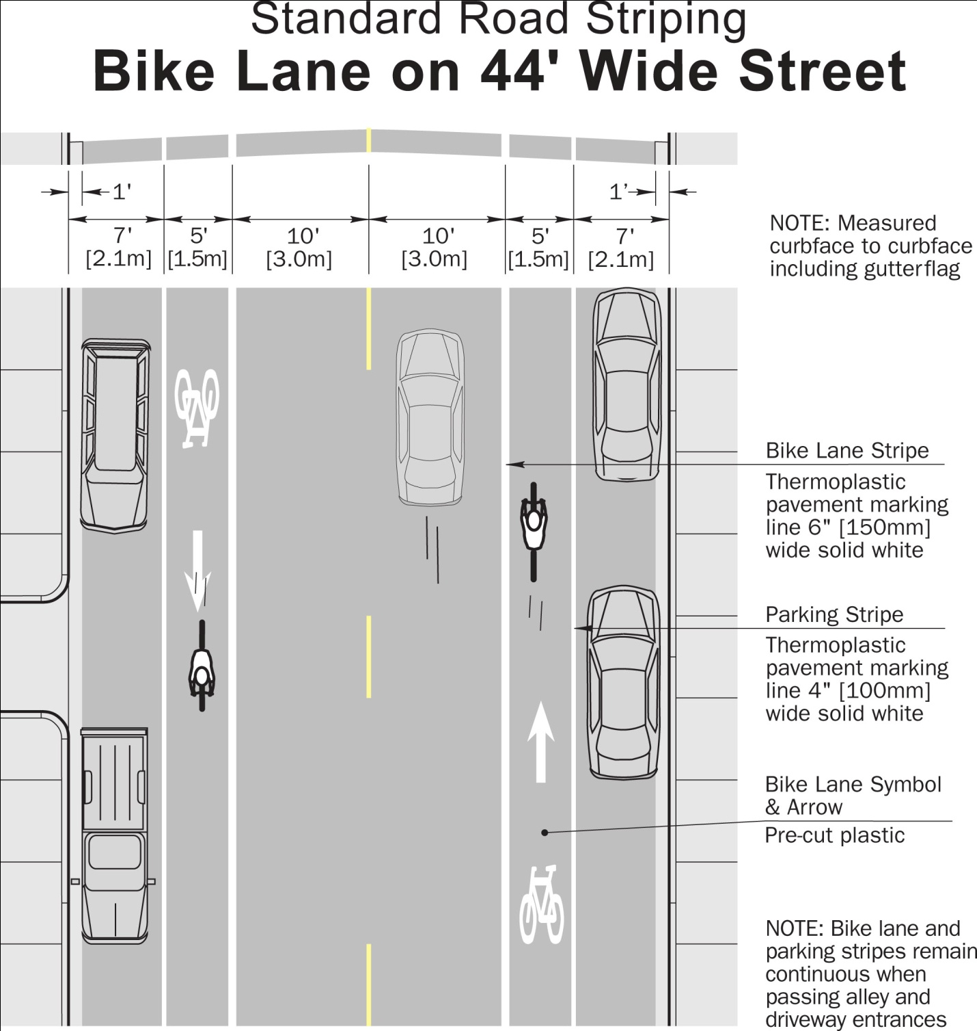
Figure 4—Bike Lane on 44’ Wide Street with Parking

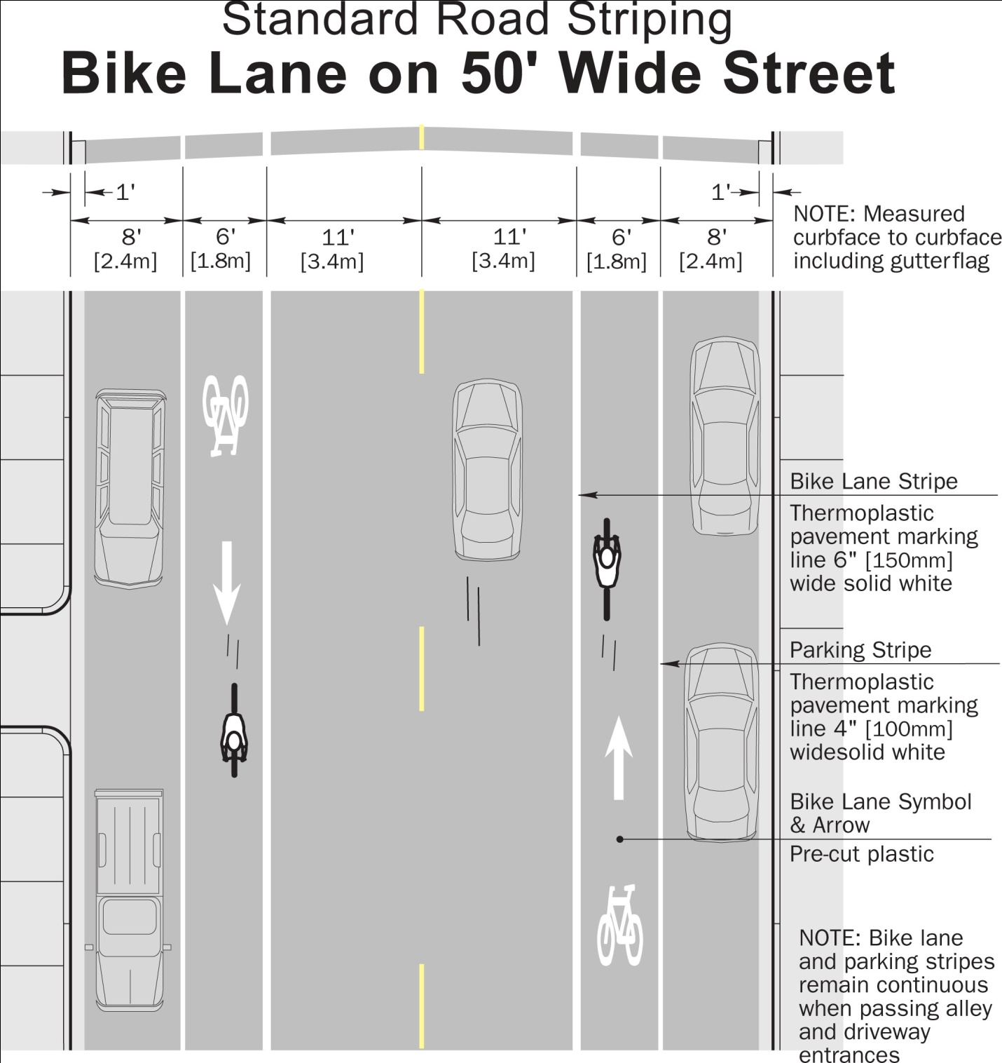
Figure 5—Bike Lane on 50’ Wide Street with Parking

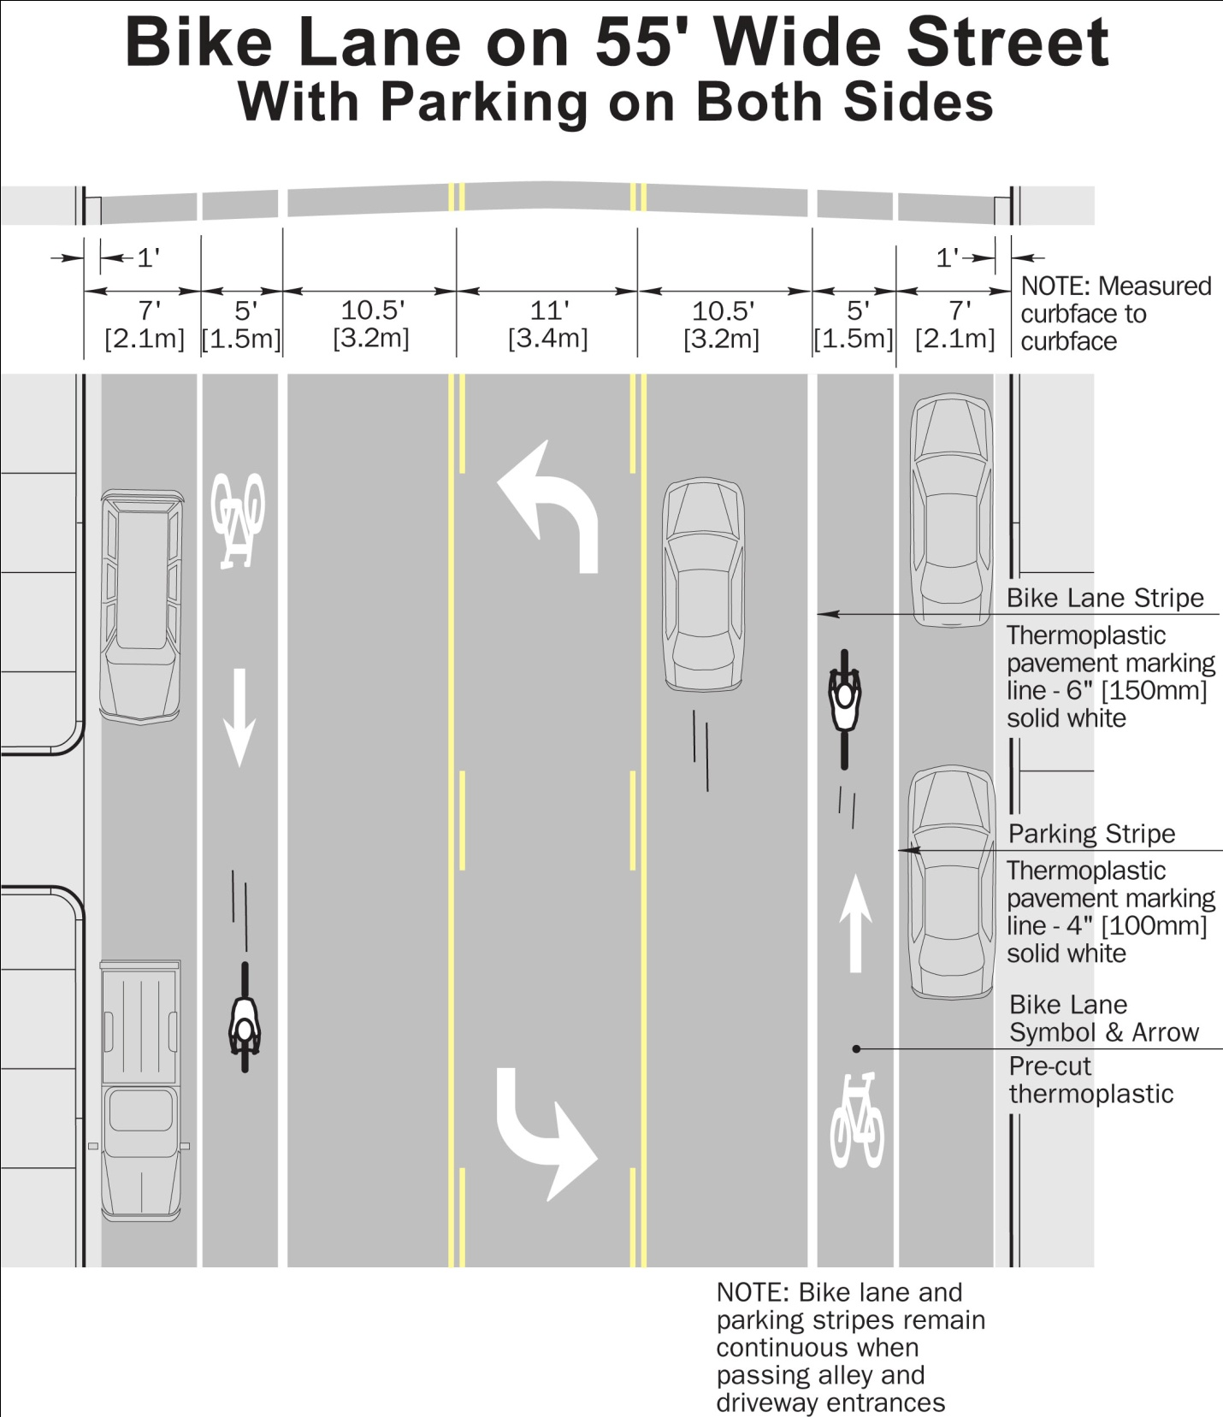
Figure 6—Bike Lane on 55’ Wide Street with Parking

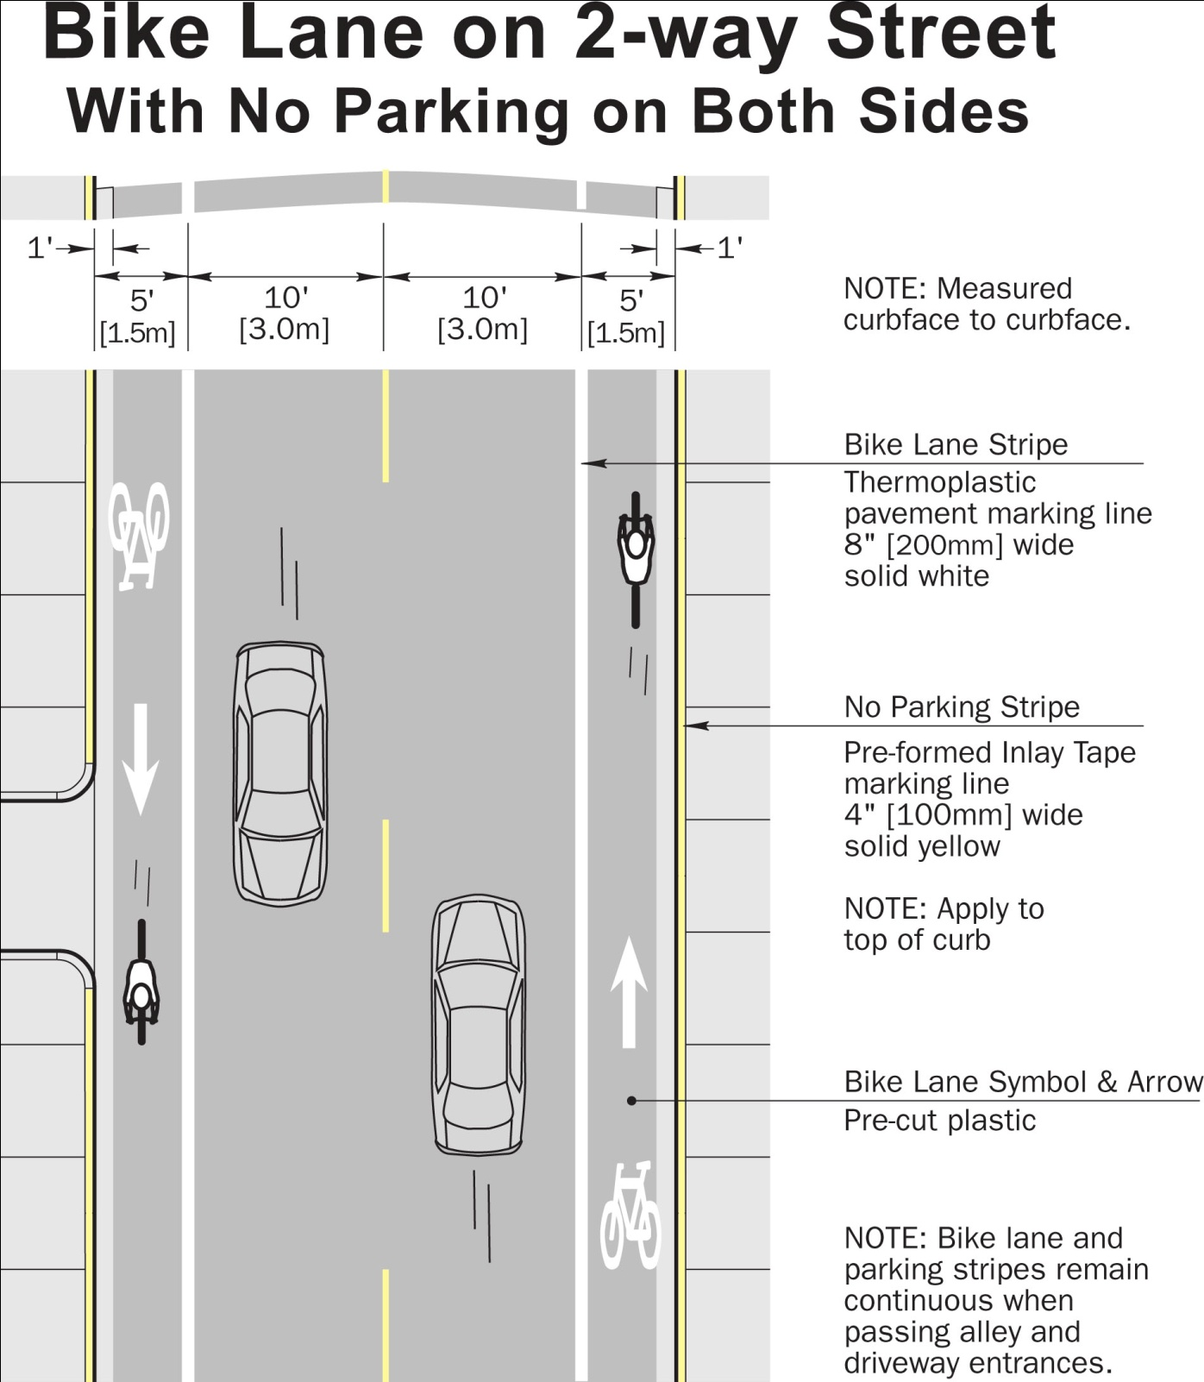
Figure 7—Bike Lane on Narrow Street with No Parking
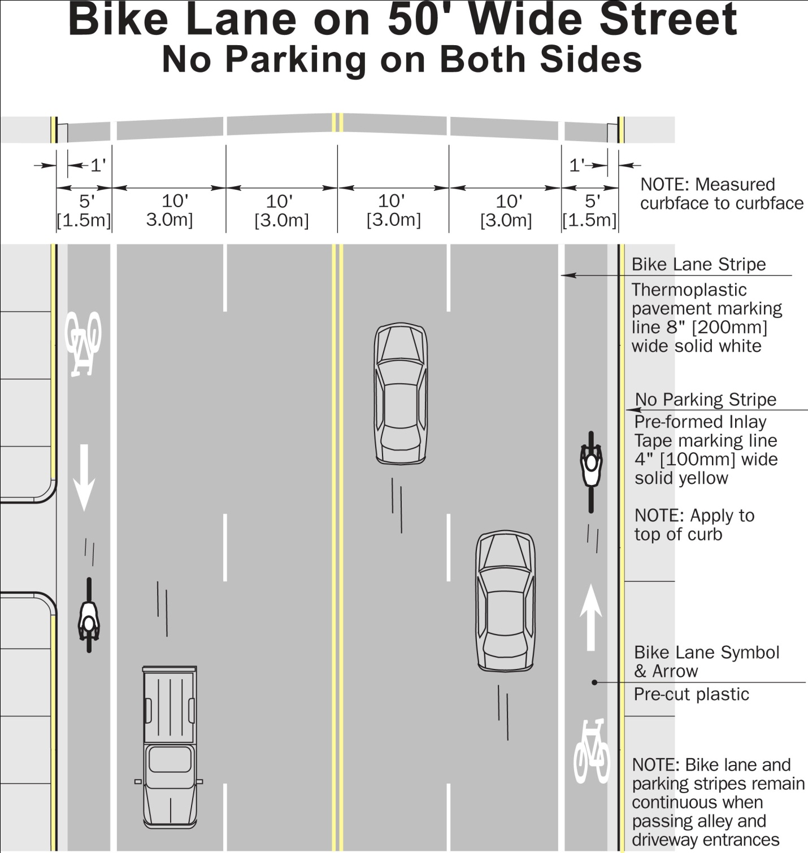
Figure 8—Bike Lane on 50’ Wide Street with No Parking

Useful Resources
City of Burlington. (2009). Bicycle Master Plan.<http://cms.burlington.ca/AssetFactory.aspx?did=14416>.
Stewart, S. (2008). Use of Roundabouts in the City of Hamilton. City of Hamilton, Public Works Department, Operations & Maintenance Division.<http://www.hamilton.ca/NR/rdonlyres/3958913C-1F44-42D7-8BD4-53760DA48789/0/PW08078UseofRoundaboutsintheCityofHamilton.pdf>.
City of Hamilton. (1999). Design Guidelines for Bikeways. <http://www.hamilton.ca/NR/rdonlyres/8A33AEA8-ACC8-422F-B537-C4C5856FCF13/0/DesignGuideforBikeways.pdf>.
City of Chicago. (2002). Bike Lane Design Guide. <http://egov.cityofchicago.org/webportal/COCWebPortal/COC_EDITORIAL/bike_lane.pdf>.

Bicycling Infrastructure Improvements Summary Chart

Route Category | Arterial Bicycling Corridors | Local Bicycling Corridors | Off-Road Bicycling Connectors
Considerations for Category | - Arterial thoroughfares where no local alternatives exist  - Slower-speed, lower-traffic alternatives preferred where possible  E.g., Paris Street, Sudbury; Ramsey Lake Road, Sudbury; Lasalle Boulevard, Sudbury; Main Street, Val Caron | - Minor thoroughfares which connect neighbourhoods or other destinations in a safe and practical way  - Preferred over arterial routes where possible  E.g., Algonquin Road, South End; Jeanne d’Arc Street, Val Thérèse; Notre Dame Street, Azilda | - Off-road trails that can be improved in conjunction with Rainbow Routes to improve the cyclability of the off-road bicycling connector  - Typically connect neighbourhoods and popular destinations  E.g., Loach’s Trail, South End
Improvements Necessary | Urban, 60 km/h or less speed limit:  - Dedicated bicycle lanes  - Sharrows where dedicated lanes are unfeasible  Rural, 80 km/h or more speed limit:  - Paved shoulder with bicycle markings (as a bicycle lane)  - Off-road cycleway or paved multi-use trail  All Arterial Bicycling Corridors:  - Bicycle Sharrows in the Short Term  - Share the Road signage  - Bicycle Route Markers | All Local Bicycling Corridors:  - Bicycle Sharrows  - Share the Road signage  - Bicycle Route Markers  Where traffic volumes are higher and space permits:  - Dedicated bicycle lanes, only in areas where there is a reasonable expectation that they can be maintained so that they are safe and practicable for cycling and not hazardous, e.g., not on roadways where sand and debris typically accumulate | Off-Road Bicycling Connectors where improvements are necessary:  - Collaboration with Rainbow Routes to improve Bicycling Connectors  All Off-Road Bicycling Connectors:  - Bicycle Route Markers

Moritz, W. E. (1998). Adult Bicyclists in the United States. Transportation Research Board, 77th Annual Meeting.< http://www.bicyclinglife.com/Library/Moritz2.htm>.
Moritz, W. E. (1998). Adult Bicyclists in the United States. Transportation Research Board, 77th Annual Meeting.< http://www.bicyclinglife.com/Library/Moritz2.htm>.
Stewart, S. (2008). Use of Roundabouts in the City of Hamilton. City of Hamilton, Public Works Department, Operations & Maintenance Division.< http://www.hamilton.ca/NR/rdonlyres/3958913C-1F44-42D7-8BD4-53760DA48789/0/PW08078UseofRoundaboutsintheCityofHamilton.pdf>.
City of Burlington. (2009). Bicycle Master Plan.<http://cms.burlington.ca/AssetFactory.aspx?did=14416>.
City of Greater Sudbury. (2005). Official Plan Transportation Schedule. <http://www.greatersudbury.ca/content/div_planning/documents/10-OPA_No-2_Transportation_Schedule%206_Aug_28_2008.pdf>.
The graphics on Pages 61—65 are adopted from: City of Chicago. (2002). Bike Lane Design Guide. <http://egov.cityofchicago.org/webportal/COCWebPortal/COC_EDITORIAL/bike_lane.pdf>.

